%Bode Plots and RC Circuit rc_w1000cutoff
% bode1and2tlh.m Plot of 1st Order System
% Obtain the Bode plot of the system given by the transfer function
% H(s) =1/(2s + 1)
% Convert the transfer function by substituting s = iw
% H( jw) = 1/(2jw + 1) if doing this by hand.
% Note H(0)= 1 (0dB). H(1/2)= -3dB. H(10*(1/2)=-20 dB
% wc= 1/2 is the break point or cutoff radian frequency.
num = 1; % 1/(2s+1) as Laplace Transfer Function
den = [2 1];
sys = tf(num,den);
figure(1)
bode(sys),grid
title('Bode Plot for 1st order system, \omega_c =0.5r/s')
%
% Obtain the bode plot of the system given by the transfer function
% hH(s) = 4 /(s^2 + s + 4) This is 4/(s^2+ 2*zeta*wn + wn^2)
num = 4;
den = [1 1 4]; % wn =2 2*zeta*wn=1 so that zeta=1/4
sys = tf(num,den);
figure(2)
bode(sys), grid
title('Bode Plot for 2st order system, \omega_n =2 r/s \zeta =.25')
% Note H2(0)= 1 (0dB). H2(10*(2)~=-40 dB

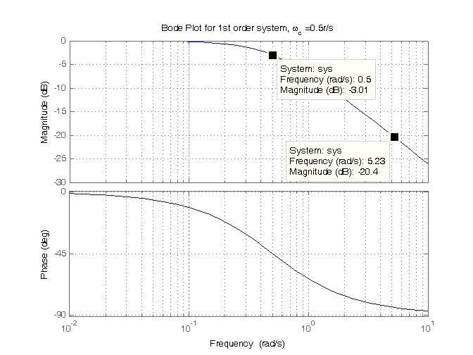

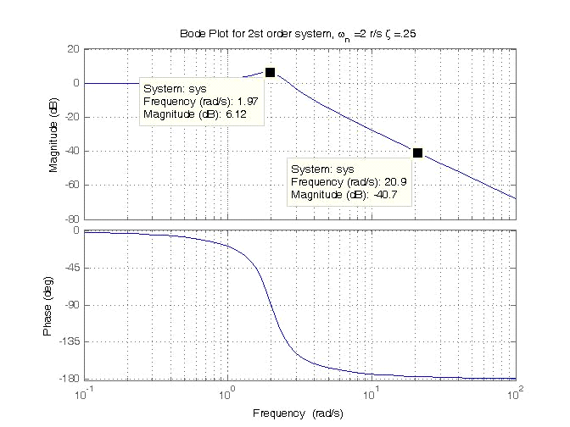

% rc_w1000cutoff See Example 8.8 Harman Eq. 8.48
clear,clc,clf
RC = 0.001; % w_c=1/RC = 1000 radians/sec
w = 0:50:5000; % Plot range in omega
H = (1/RC)./(j*w+1/RC);
magH = abs(H); angH = 180*angle(H)/pi;
figure(1),subplot(211),plot(w,magH)
title('Series RC, \omega_c = 1000 r/s')
xlabel('Frequency (rad/sec)')
ylabel('|H|'),grid
% the following adds lines that identify the points
% where |H|=.707
hold on
plot([800 1000],[.707 .707],'r:') %,...
hold off
text(200,.707,'0.707'),subplot(212),plot(w,angH);
axis([0 5000 -90 0])
xlabel('Frequency (rad/sec)'),ylabel('Angle(H), degrees'),grid
% Bode Plot H= (1/RC)/(s+1/RC) 1/RC=1000
figure(2)
num=1000
den=[1 1000]
sysrc=tf(num,den)
bode(sysrc),grid
title('Bode diagram for RC circuit \omega_c = 1000 r/s')
hold
gtext('Use Tools/Data Cursor for Values')
hold off
