CENG 5131 Engineering Applications
Study of modern engineering techniques emphasizing mathematical methods currently used in industry. The MATLAB software package will be used for problem solving.

Prerequisites
Linear Systems Analysis or equivalent.
WE WILL LOG ON TO MY WEB SITE AND REVIEW THE SYLLABUS

http://sceweb.sce.uhcl.edu/harman/ MY WEB SITE

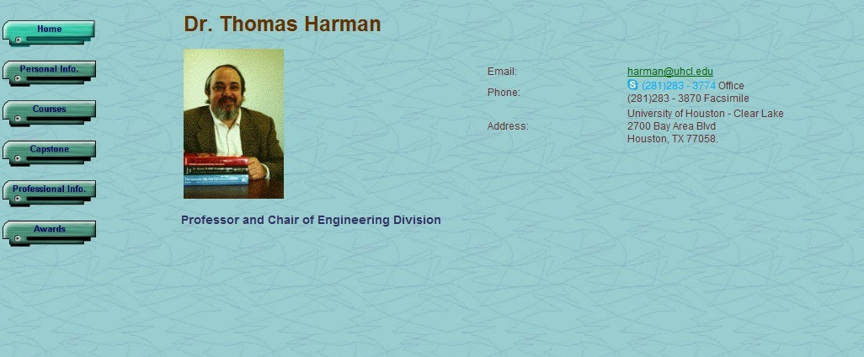

Please view my WEB site for the Syllabus and other material for the course.

- THE WEBSITE FOR THE COURSE: http://sceweb.sce.uhcl.edu/harman/

- The user and password for Courses Tab to the left of the screen will be:

Username: sce\cengcourses
Passwd: tlhcourses

- After Courses opens, Scroll to CENG 5131 and click on the link you want – Syllabus, etc.
http://sceweb.sce.uhcl.edu/harman/CENG5131/2014Syllabus/5131_f2014Syllabus.pdf
- LET’S LOOK AT THE “BIG PICTURE:
Linear Systems

http://sceweb.sce.uhcl.edu/harman/CENG5131/FirstDayWeb_bigpicture/BigPictureLinearReview5131F2014.PDF

Good luck
T.L. Harman

