CHAPTER 11 Project Risk Management
Project Risk Management includes the processes concerned with conducting risk management planning, identification, analysis, responses, and monitoring and contro1 on a project; most of these processes are updated throughout the project. The objectives of Project Risk Management are to increase the probability and impact of positive events, and decrease the probability and impact of events adverse to the project. Figure 11-1 provides an overview of the Project Risk Management processes.
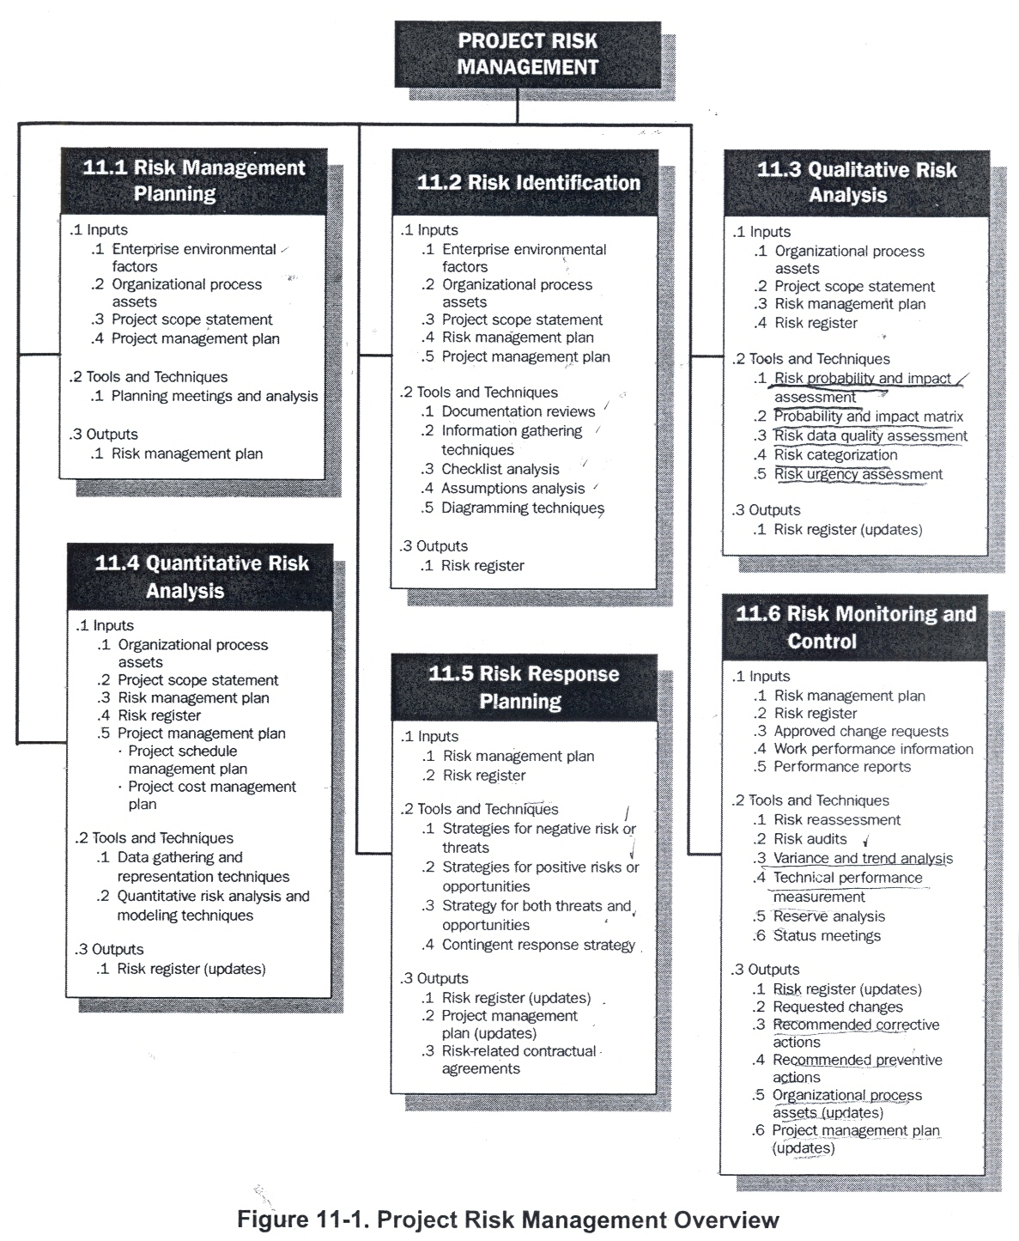
Figure 11-2 provides a process flow diagram of those processes and their inputs, outputs, and other related Knowledge Area processes.

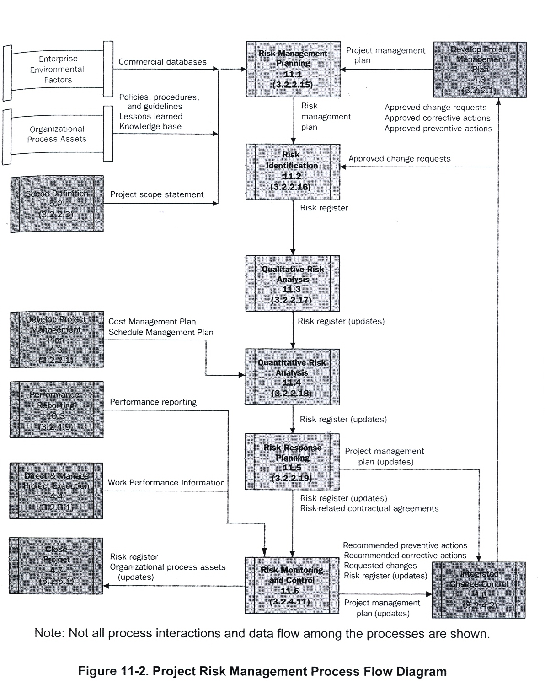

The six Project Risk Management processes include the following:

11.1 Risk Management Planning - deciding how to approach, plan, and execute the risk management activities for a project.

11.2 Risk Identification - determining which risks might affect the project and documenting their characteristics.

11.3 Qualitative Risk Analysis - prioritizing risks for subsequent further analysis or action by assessing and combining their probability of occurrence and impact.

11.4 Quantitative Risk Analysis - numerically analyzing the effect on overall project objectives of identified risks.

11.5 Risk Response Planning - developing options and actions to enhance opportunities, and to reduce threats to project objectives.

11.6 Risk Monitoring and Control - tracking identified risks, monitoring residual risks, identifying new risks, executing risk response plans, and evaluating their effectiveness throughout the project life cycle.

These processes interact with each other and with the processes in the other Knowledge Areas as well. Each process can involve effort from one or more persons or groups of persons based on the needs of the project. Each process occurs at least once in every project and occurs in one or more project phases, if the project is divided into phases. Although the processes are presented here as discrete elements with well-defined interfaces, in practice they may overlap and interact in ways not detailed here.

Project risk is an uncertain event or condition that, if it occurs, has a positive or a negative effect on at least one project objective, such as time, cost, scope, or quality (i.e., where the project time objective is to deliver in accordance with the agreed-upon schedule; where the project cost objective is to deliver within the agreed-upon cost; etc.). A risk may have one or more causes and, if it occurs, one or more impacts. For example, a cause may be requiring an environmental permit to do work, or having limited personnel assigned to design the project. The risk event is that the permitting agency may take longer than planned to issue a permit, or the design personnel available and assigned may not be adequate for the activity. If either of these uncertain events occurs, there may be an impact on the project cost, schedule, or performance. Risk conditions could include aspects of the project's or organization's environment that may contribute to project risk, such as poor project management practices, lack of integrated management systems, concurrent multiple projects, or dependency on external participants who cannot be controlled.

Project risk has its origins in the uncertainty that is present in all projects. Known risks are those that have been identified and analyzed, and it may be possible to plan for those risks using the processes described in this chapter. Unknown risks cannot be managed proactively, and a prudent response by the project team can be to allocate general contingency against such risks, as well as against any known risks for which it may not be cost-effective or possible to develop a proactive response.

Organizations perceive risk as it relates to threats to project success, or to opportunities to enhance chances of project success. Risks that are threats to the project may be accepted if the risk is in balance with the reward that may be gained by taking the risk. For example, adopting a fast track schedule that may be overrun is a risk taken to achieve an earlier completion date. Risks that are opportunities, such as work acceleration that may be gained by assigning additional staff, may be pursued to benefit the project's objectives.

Persons and, by extension, organizations have attitudes toward risk that affect both the accuracy of the perception of risk and the way they respond. Attitudes about risk should be made explicit wherever possible. A consistent approach to risk that meets the organization's requirements should be developed for each project, and communication about risk and its handling should be open and honest. Risk responses ref1ect an organizations perceived balance between risk-taking and risk avoidance.

To be successful, the organization should be committed to addressing the management of risk proactively and consistently throughout the project.

11.1 Risk Management Planning

Careful and explicit planning enhances the possibility of success of the five other risk management processes. Risk Management Planning is the process of deciding how to approach and conduct the risk management activities for a project. Planning of risk management processes is important to ensure that the level, type, and visibility of risk management are commensurate with both the risk and importance of the project to the organization, to provide sufficient resources and time for risk management activities, and to establish an agreed-upon basis for evaluating risks. The Risk Management Planning process should be completed early during project planning, since it is crucial to successfully performing the other processes described in this chapter.

INPUTS | Tools & Techniques | Outputs
- Enterprise environmental factors | - Planning Meetings and analysis | - Risk Management Plan
- Organizational process assets
- Project scope statement
- Project management plan

Figure 11-3. Risk Management Planning: Inputs, Tools & Techniques, and Outputs
------------------------------------------------------------------

11.1.1 Risk Management Planning: Inputs

1. Enterprise Environmental Factors

The attitudes toward risk and the risk tolerance of organizations and people involved in the project will influence the project management plan (Section 4.3). Risk attitudes and tolerances may be expressed in policy statements or revealed in actions (Section 4.1.1.3).

2. Organizational Process Assets Organizations may have predefined approaches to risk management such as risk categories, common definition of concepts and terms, standard templates, roles and responsibilities, and authority levels for decision-making.

3. Project Scope Statement Described in Section 5.2.3.1.

4. Project Management Plan Described in Section 4.3.

11.1.2 Risk Management Planning: Tools and Techniques

1. Planning Meetings and Analysis

Project teams hold planning meetings to develop the risk management plan. Attendees at these meetings may include the project manager, selected project team members and stakeholders, anyone in the organization with responsibility to manage the risk planning and execution activities, and others, as needed.

Basic plans for conducting the risk management activities are defined in these meetings. Risk cost elements and schedule activities will be developed for inclusion in the project budget and schedule, respectively. Risk responsibilities will be assigned. General or-organizational templates for risk categories and definitions of terms such as levels of risk, probability by type of risk, impact by type of objectives, and the probability and impact matrix will be tailored to the specific project. The outputs of these activities will be summarized in the risk management plan.

11.1.3 Risk Management Planning: Outputs

1. Risk Management Plan

The risk management plan describes how risk management will be structured and performed on the project. It becomes a subset of the project management plan (Section 4.3). The risk management plan includes the following:
- Methodology. Defines the approaches, tools, and data sources that may be used to perform risk management on the project.
- Roles and responsibilities. Defines the lead, support, and risk management team membership for each type of activity in the risk management plan, assigns people to these roles, and clarifies their responsibilities.
- Budgeting. Assigns resources and estimates costs needed for risk management for inclusion in the project cost baseline (Section 7.2.3. I).
- Timing. Defines when and how often the risk management process will be performed throughout the project life cycle, and establishes risk management activities to be included in the project schedule (Section 6.5.3.1).
- Risk categories. Provides a structure that ensures a comprehensive process of systematically identifying risk to a consistent level of detail and contributes to the effectiveness and quality of Risk Identification. An organization can use a previously prepared categorization of typical risks. A risk breakdown structure (RES) (Figure 11-4) is one approach to providing such a structure, but it can also be addressed by simply listing the various aspects of the project. The risk categories may be revisited during the Risk Identification process. A good practice is to review the risk categories during the Risk Management Planning process prior to their use in the Risk Identification process. Risk categories based on prior projects may need to be tailored, adjusted, or extended to new situations before those categories can be used on the current project.
- Definitions of risk probability and impact. The quality and credibility of the Qualitative Risk Analysis process requires that different levels of the risks' probabilities and impacts be defined. General definitions of probability levels and impact levels are tailored to the individual project during the Risk Management Planning process for use in the Qualitative Risk Analysis process (Section 11.3).
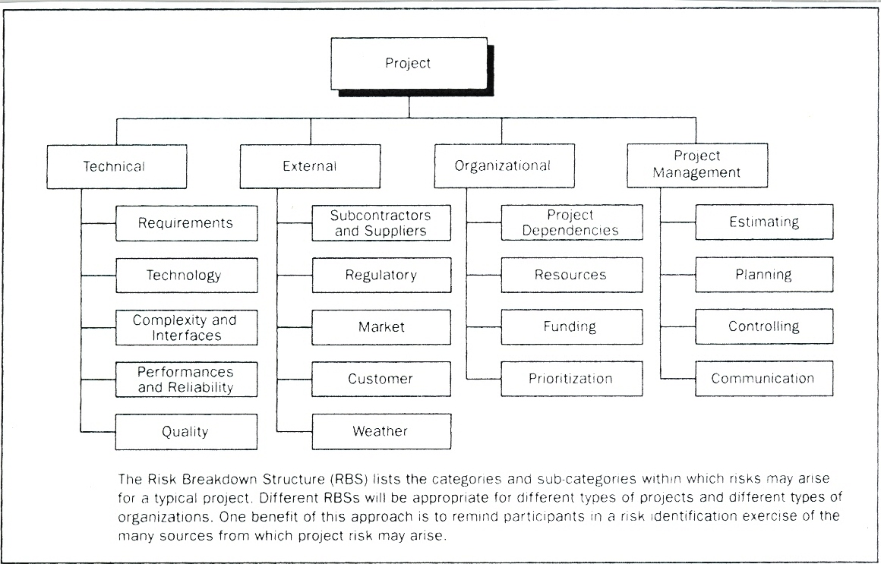
Figure 11-4. Example of a Risk Breakdown Structure (RBS)

A relative scale representing probability values from "very unlikely" to "almost certainty" could be used. Alternatively, assigned numerical probabilities on a general scale (e.g., 0.1, 0.3, 0.5, 0.7, 0.9) can be used. Another approach to calibrating probability involves developing descriptions of the state of the project that relate to the risk under consideration (e.g., the degree of maturity of the project design).

The impact scale ret1ects the significance of impact, either negative for threats or positive for opportunities, on each project objective if a risk occurs. Impact scales are specific to the objective potentially impacted, the type and size of the project, the organization's strategies and financial state, and the organization's sensitivity to particular impacts. Relative scales for impact are simply rank-ordered descriptors such as "very low," "low," "moderate," "high," and "very high," reflecting increasingly extreme impacts as defined by the organization. Alternatively, numeric scales assign values to these impacts. These values may be linear (e.g., 0.1, 0.3, 0.5, 0.7, 0.9) or nonlinear (e.g., 0.05, 0.1, 0.2, 0.4, 0.8). Nonlinear scales may represent the organization's desire to avoid high-impact threats or exploit high-impact opportunities, even if they have relatively low probability. In using nonlinear scales, it is important to understand what is meant by the numbers and their relationship to each other, how they were derived, and the effect they may have on the different objectives of the project.

Figure 11-5 is an example of negative impacts of definitions that might be used in evaluating risk impacts related to four project objectives. Figure 11-5 illustrates both relative and numeric (in this case, nonlinear) approaches. The figure is not intended to imply that the relative and numeric terms are equivalent, but to show the two alternatives in one figure rather than one.

Defined Conditions for Impact Scales of a Risk on Major Project Objectives
(Examples are shown for negative impacts only)
Project Objective | Relative or numerical scales are shown
 | Very low /.05 | Low /.10 | Moderate /.20 | High /.40 |  | Very high /.80
Cost | Insignificant cost  increase | <10% cost  increase | 10-20% cost  increase | 20-40% cost  increase | >40% cost  increase
Time | Insignificant time  increase | <5% time  increase | 5-10% time  increase | 10-20% time  increase | >20% time  increase
Scope | Scope decrease barely noticeable | Minor areas of scope affected | Major areas of scope affected | Scope reduction unacceptable to sponsor | Project end item is effectively useless
Quality | Quality degradation barely noticeable | Only very demanding applications are affected | Quality reduction requires sponsor approval | Quality reduction unacceptable to sponsor | Project end item is effectively useless
This table presents examples of risk impact definitions for four different project objectives. They should be tailored in the Risk Management Planning process to the individual project and to the organization's risk thresholds. Impact definitions can be developed for opportunities in a similar way.

Figure 11-5. Definition of Impact Scales for Four Project Objectives
- Probability and impact matrix. Risks are prioritized according to their potential implications for meeting the project's objectives. The typical approach to prioritizing risks is to use a look-up table or a Probability and Impact Matrix (Figure 11-8 and Section 11.3.2.2). The specific combinations of probability and impact that lead to a risk being rated as "high," "moderate," or "low" importance-with the corresponding importance for planning responses to the risk (Section 11.5)-are usually set by the organization. They are reviewed and can be tailored to the specific project during the Risk Management Planning process.
- Revised stakeholders' tolerances. Stakeholders' tolerances may be revised in the Risk Management Planning process, as they apply to the specific project.
- Reporting formats. Describes the content and format of the risk register (Sections 11.2, 11.3, 1104, and 11.5) as well as any other risk reports required. Defines how the outcomes of the risk management processes will be documented, analyzed, and communicated.
- Tracking. Documents how all facets of risk activities will be recorded for the benefit of the current project, future needs, and lessons learned. Documents whether and how risk management processes will be audited.

11.2 Risk Identification

Risk Identification determines which risks might affect the project and documents their characteristics. Participants in risk identification activities can include the following, where appropriate: project manager, project team members, risk management team (if assigned), subject matter experts from outside the project team, customers, end users, other project managers, stakeholders, and risk management experts. While these personnel are often key participants for risk identification, all project personnel should be encouraged to identify risks.

Risk Identification is an iterative process because new risks may become known as the project progresses through its life cycle (Section 2.1). The frequency of iteration and who participates in each cycle will vary from case to case. The project team should be involved in the process so that they can develop and maintain a sense Of ownership and responsibility for, the risks and associated risk response actions. Stakeholders outside the project team may provide additional objective information. The Risk Identification process usually leads to the Qualitative Risk Analysis process (Section 11.3). Alternatively it can lead directly to the Quantitative Risk Analysis process (section 11.4) when conducted by an experienced risk manager. On some occasions, simply the identification of a risk may suggest its response, and these should be recorded for further analysis and implementation in the Risk Response Planning process (Section 11.5).

INPUTS | Tools & Techniques | Outputs
- Enterprise environmental factors | - Documentation reviews | - Risk register
- Organizational process assets | - Information gathering techniques
- Project scope statement | - Checklist analysis
- Project management plan | - Assumptions analysis
 | - Diagramming techniques

Figure 11-6. Risk Identification: Inputs, Tools & Techniques, and Outputs

11.2.1 Risk Identification: Inputs

1. Enterprise Environmental Factors
Published information, including commercial databases, academic studies, benchmarking, or other industry studies, may also be useful in identifying risks (Section 4.1.1.3).

- Organizational Process Assets
Information on prior projects may be available from previous project files, including actual data and lessons learned (Section 4.1.1.4).

3. Project Scope Statement
Project assumptions are found in the project scope statement (Section 5.2.3.1). Uncertainty in project assumptions should be evaluated as potential causes of project risk.

4. Risk Management Plan
Key inputs from the risk management plan to the Risk Identification process are the assignments of roles and responsibilities, provision for risk management activities in the budget and schedule, and categories of risk (Section 11.1.3.1), which are sometimes expressed in an RBS (Figure 11-4) .

5. Project Management Plan
The Risk Identification process also requires an understanding of the schedule, cost, and quality management plans found in the project management plan (Section 4.3). Outputs of other Knowledge Area processes should be reviewed to identify possible risks across the entire project.

11.2.2 Risk Identification: Tools and Techniques

- Documentation Reviews
A structured review may be performed of project documentation, including plans, assumptions, prior project files, and other information. The quality of the plans, as well as consistency between those plans and with the project requirements and assumptions, can be indicators of risk in the project.

- Information Gathering Techniques
Examples of information gathering techniques used in identifying risk can include:
- Brainstorming. The goal of brainstorming is: to obtain a comprehensive list of project risks. The project team usually performs brainstorming, often with a multidisciplinary set of experts not on the team. Ideas about project risk are gathered under the leadership of facilitation. Categories of risk (Section 11.1), such as a risk breakdown structure, can be used as a framework. Risks are then identified and categorized by type of risk and their definitions are sharpened.
- Delphi technique. The Delphi technique is a way to reach a consensus of experts. Project risk experts participate in. this technique anonymously. A facilitator uses a questionnaire to solicit ideas about the important project risks. The responses are summarized and are then recirculated to the experts for further comment. Consensus may be reached in a few rounds of this process. The Delphi technique helps reduce bias in the data and keeps any one person from having undue influence on the outcome.
- Interviewing. Interviewing experienced project participants, stakeholders, and subject matter experts can identify risks. Interviews are one of the main sources of risk identification data gathering.
- Root cause identification. This is an inquiry into the essential causes of a project's risks. It sharpens the definition of the risk and allows grouping risks by causes. Effective risk responses can be developed if the root cause of the risk is addressed.
- Strengths, weaknesses, opportunities, and threats (SWOT) analysis. This technique ensures examination of the project from each of the SWOT perspectives, to increase the breadth of considered risks.

- Checklist Analysis

Risk identification checklist can be developed based on historical information and knowledge that has been accumulated from previous similar projects and from other sources of information. The lowest level of the RBS can also be used as a risk checklist. While a checklist can be quick and simple, it is impossible to build an exhaustive one. Care should be taken to explore items that do not appear on the checklist. The checklist should be reviewed during project closure to improve it for use on future projects.

- Assumptions Analysis

Every project is conceived and developed based on a set of hypotheses, scenarios, or assumptions. Assumptions analysis is a tool that explores the validity of assumptions as they apply to the project. It identifies risks to the project from inaccuracy, inconsistency, or incompleteness of assumptions.

- Diagramming Techniques
Risk diagramming techniques may include:
  - Cause-and-effect diagrams (Section 8.3.2.1). These are also known as Ishikawa or fishbone diagrams, and are useful for identifying causes of risks.
  - System or process flow charts. These show how various elements of a system interrelate, and the mechanism of causation (Section 8.3.2.3).
  - Influence diagrams. These are graphical representations of situations showing causal influences, time ordering of events, and other relationships among variables and outcomes.

11.2.3 Risk Identification: Outputs
The outputs from Risk Identification are typically contained in a document that can be called a risk register.

1. Risk Register

The primary outputs from Risk Identification are the initial entries into the risk register, which becomes a component of the project management plan (Section 4.3). The risk register ultimately contains the outcomes of the other risk management processes as they are conducted. The preparation of the risk register begins in the Risk Identification process with the following information, and then becomes available to other project management and Project Risk Management processes.

- List of identified risks. The identified risks, including their root causes and uncertain project assumptions, are described. Risks can cover nearly any topic, but a few examples include the following: A few large items with long lead times are on critical path. There could be a risk that industrial relations disputes at the ports will delay the delivery and, subsequently, delay completion of the construction phase. Another example is a project management plan that assumes a staff size of ten, but there are only six resources available. The lack of resources could impact the time required to complete the work and the activities would be late.
- List of potential responses. Potential responses to a risk may be identified during the Risk Identification process. These responses, if identified may be useful as inputs to the Risk Response Planning process(Section 11.5)
- Root causes of risk. These are the fundamental conditions or events that may give rise to the identified rise.
- Updated risk categories. The process of identifying risks can lead to new risk categories being added to the list of risk categories. The RBS developed in the Risk Management Planning process may have to be enhanced or amended, based on the outcomes of the Risk Identification process.

11.3 Qualitative Risk Analysis

Qualitative Risk Analysis includes methods for prioritizing the identified risks for further action, such as Quantitative Risk Analysis (Section 11.4) or Risk Response Planning (Section 11.5). Organizations can improve the project's performance effectively by focusing on high-priority risks. Qualitative Risk Analysis assesses the priority of identified risks using their probability of occurring, the corresponding impact on project objectives if the risks do occur, as well as other factors such as the time frame and risk tolerance of the project constraints of cost, schedule, scope, and quality.

Definitions of the levels of probability and impact, and expert interviewing, can help to correct biases that are often present in the data used in this process. The time criticality of risk-related actions may magnify the importance of a risk. An evaluation of the quality of the available information on project risks also helps understand the assessment of the risk's importance to the project.

Qualitative Risk Analysis is usually a rapid and cost-effective means of establishing priorities for Risk Response Planning, and lays the foundation for Quantitative Risk Analysis, if this is required. Qualitative Risk Analysis should be revisited during the project's life cycle to stay current with changes in the project risks. Qualitative Risk Analysis requires outputs of the Risk Management Planning (Section 11.1) and Risk Identification (Section 11.2) processes. This process can lead into Quantitative Risk Analysis (Section 11.4) or directly into Risk Response Planning (Section 11.5).
INPUTS | Tools & Techniques | Outputs
- Organizational process assets | - Risk probability and impact assessment | - Risk register (updates)
- Project scope statement | - Probability and impact matrix
- Risk management plan | - Risk data quality assessment
- Risk register | - Risk categorization
 | - Risk urgency assessment

Figure 11-7. Qualitative Risk Analysis: Inputs, Tools & Techniques, and Outputs

11.3.1 Qualitative Risk Analysis: Inputs

- Organizational Process Assets

Data about risks on past projects and the lessons learned knowledge base can be used in the Qualitative Risk Analysis process.

- Project Scope Statements

Projects of a common or recurrent type tend to have more well-understood risks. Projects using state-of-the-art or first-of-its-kind technology, and highly complex projects, tend to have more uncertainty. This can be evaluated by examining the project scope statement (Section 5.2.3.1).

- Risk Management Plan

Key elements of the risk management plan for Qualitative Risk Analysis include roles and responsibilities for conducting risk management, budgets, and schedule activities for risk management, risk categories, definition of probability and impact, the probability and impact matrix, and revised stakeholders' risk tolerances (also enterprise environmental factors in Section 4.1.1.3). These inputs are usually tailored to the project during the Risk Management Planning process. If they are not available, they can be developed during the Qualitative Risk Analysis process.

- Risk Register

A key item from the risk register for Qualitative Risk Analysis is the list of identified risks (Section 11.2.3.1).

11.3.2 Qualitative Risk Analysis: Tools and Techniques

- Risk Probability and Impact Assessment

Risk probability assessment investigates the likelihood that each specific risk will occur. Risk impact assessment investigates the potential effect on a project objective such as time, cost, scope, or quality, including both negative effects for threats and positive effects for opportunities.

Probability and impact are assessed for each identified risk. Risks can be assessed in interviews or meetings with participants selected for their familiarity with the risk categories on the agenda. Project team members and, perhaps, knowledgeable persons from outside the project, are included. Expert judgment is required, since there may be little information on risks from the organization's database of past projects. An experienced facilitator may lead the discussion, since the participants may have little experience with risk assessment.

The level of probability for each risk and its impact on each objective is evaluated during the interview or meeting. Explanatory detail, including assumptions justifying the levels assigned, is also recorded. Risk probabilities and impacts are rated according to the definitions given in the risk management plan (Section 11.1.3.1). Sometimes, risks with obviously low ratings of probability and impact will not be rated, but will be included on a watch list for future monitoring.

- Probability and Impact Matrix

Risks can be prioritized for further quantitative analysis (Section 11.4) and response (Section 11.5), based on their risk rating. Ratings are assigned to risks based on their assessed probability and impact (Section 11.3.2.2). Evaluation of each risk's importance and, hence, priority for attention is typically conducted using a look-up table or a probability and impact matrix (Figure 11-8). Such a matrix specifies combinations of probability and impact that lead to rating the risks as low, moderate, or high priority. Descriptive terms or numeric values can be used, depending on organizational preference.

The organization should determine which combinations of probability and impact result in a classification of high risk ("red condition"), moderate risk ("yellow condition"), and low risk ("green condition"). In a black-and-white matrix, these conditions can be denoted by different shades of gray. Specifically, in Figure 11-8, the dark gray area (with the largest numbers) represents high risk; the medium gray area (with the smallest numbers) represents low risk; and the light gray area (with in-between numbers) represents moderate risk. Usually, these risk rating rules are specified by the organization in advance of the, project, and included in organizational process (Section 4.1.1.4). Risk rating rules can be tailored in the Risk Management Planning process (Section 11.1) to the specific project. A probability and impact matrix, such as the one shown in Figure 11-8, is often used.
 | Probability and Impact Matrix
 | Probability | Threats |  |  |  |  | Opportunities
0.90 |  | 0.05 | 0.09 | 0.18 | 0.36 | 0.72 | 0.72 | 0.36 | 0.18 | 0.09 | 0.05
0.75 |  | 0.04 | 0.07 | 0.14 | 0.28 | 0.56 | 0.56 | 0.28 | 0.14 | 0.07 | 0.04
0.50 |  | 0.03 | 0.05 | 0.10 | 0.20 | 0.40 | 0.40 | 0.20 | 0.10 | 0.05 | 0.03
0.30 |  | 0.02 | 0.03 | 0.06 | 0.12 | 0.24 | 0.24 | 0.12 | 0.06 | 0.03 | 0.02
0.10 |  | 0.01 | 0.01 | 0.02 | 0.04 | 0.08 | 0.08 | 0.04 | 0.02 | 0.01 | 0.01
 |  | 0.05 | 0.10 | 0.20 | 0.40 | 0.80 | 0.80 | 0.40 | 0.20 | 0.10 | 0.05
Impact (ratio scale) on an objective (e.g., cost, time, scope or quality)

Each risk is rated on its probability of occurring and impact on an objective if it does occur. The organization’s thresholds for low, moderate or high risk are shown in the matrix and determined whether the risk is scored as high, moderate or low for that objective.
Figure 11-8. Probability and Impact Matrix

As illustrated in Figure 11-8, an organization can rate a risk separately for each objective (e.g., cost, time, and scope). In addition, it can develop ways to determine one overall rating for each risk. Finally, opportunities and threats can be handled in the same matrix using definitions of the different levels of impact that are appropriate for each.

The risk score helps guide risk responses. For example, risks that have a negative impact on objects if they occur (threats), and that are in the high-risk (dark gray) zone go the matric, may require priority action and aggressive response strategies. Threats in the low-risk (medium gray) zone may not require proactive management action beyond being placed on a watch list or adding a contingency.

Similarly for opportunities, those in the high risk (dark green) zone that can be obtained most easily and offer the greatest benefit should, therefore, be targeted first. ·Opportunities in the low risk (medium gray) zone should be monitored.

- Risk Data Quality Assessment

A qualitative risk analysis requires accurate and unbiased data if it is to be credible. Analysis of the quality of risk data is a technique to evaluate the degree to which the data about risks is useful for risk management. It involves examining the degree to which the risk is understood and the accuracy, quality, reliability, and integrity of the data about the risk.

The use of low-quality risk data may lead to a qualitative risk analysis of little use to the project. If data quality is unacceptable, it may be necessary to gather better data. Often, collection of information about risks is difficult, and consumes time and resources beyond that originally planned.

- Risk Categorization

Risks to the project can be categorized by sources of risk (e.g., using the RBS), the area of the project affected (e.g., using the WBS), or other useful category (e.g., project phase) to determine areas of the project most exposed to the effects of uncertainty. Grouping risks by common root causes can lead to developing effective risk responses.

- Risk Urgency Assessment

Risks requiring near-term responses may be considered more urgent to address. Indicators of priority can include time to affect a risk response, symptoms and warning signs, and the risk rating.

11.3.3 Qualitative Risk Analysis: Outputs

- Risk Register (Updates)

The risk register is initiated during the Risk Identification process. The risk register is updated with information from Qualitative Risk Analysis and the updated risk register is included in the project management plan. The risk register updates from Qualitative Risk Analysis include:

- Relative ranking or priority list of project risks. The probability and impact matrix can be used to classify risks according to their individual significance. The project manager can then use the prioritized list to focus attention on those items of high significance to the project, where responses can lead to better project outcomes. Risks may be listed by priority separately for cost, time, scope, and quality, since organizations may value one objective over another. A description of the basis for the assessed probability and impact should be included for risks assessed as important to the project.
- Risks grouped by categories. Risk categorization can reveal common root causes of risk or project areas requiring particular attention. Discovering concentrations of risk may improve the effectiveness of risk responses.
- List of risks requiring response in the near-term. Those risks that require an urgent response and those that can be handled at a later date may be put into different groups.
- List of risks for additional analysis and response. Some risks might warrant more analysis, including Quantitative Risk Analysis, as well as response action.
- Watch lists of low priority risks. Risks that are not assessed as important in the Qualitative Risk Analysis process can be placed on a watch list for continued monitoring.
- Trends in qualitative risk analysis results. As the analysis is repeated, a trend for particular risks may become apparent, and can make risk response or further analysis more or less urgent/important.

11.4 Quantitative Risk Analysis

Quantitative Risk Analysis is performed on risks that have been prioritized by the Qualitative Risk Analysis process as potentially and substantially impacting the project's competing demands. The Quantitative Risk Analysis process analyzes the effect of those risk events and assigns a numerical rating to those risks. It also presents a quantitative approach to making decisions in the presence of uncertainty. This process uses techniques such as Monte Carlo simulation and decision tree analysis to:
- Quantify the possible outcomes for the project and their probabilities
- Assess the probability of achieving specific project objectives
- Identify risks requiring the most attention by quantifying their relative contribution to overall project risk
- Identify realistic and achievable cost, schedule, or scope targets, given the project risks
- Determine the best project management decision when some conditions or outcomes are uncertain.

Quantitative Risk Analysis generally follows the Qualitative Risk Analysis process, although experienced risk managers sometimes perform it directly after Risk Identification. In some cases, Quantitative Risk Analysis may not be required to develop effective risk responses. Availability of time and budget, and the need for qualitative or quantitative statements about risk and impacts, will determine which methods) to use on any particular project. Quantitative Risk Analysis should be repeated after Risk Response Planning, as well as part of Risk Monitoring and Control, to determine if the overall project risk has been satisfactorily decreased. Trends can indicate the need for more or less risk management action. It is an input to the Risk Response Planning process.

INPUTS | Tools & Techniques | Outputs
- Organizational process assets | - Data gathering and representation techniques | - Risk register (updates)
- Project scope statement | - Quantitative risk analysis and modeling techniques
- Risk management plan
- Risk register
- Project management plan
- Project schedule management plan
- Project cost management plan

Figure 11-9. Quantitative Risk Analysis: Inputs, Tools & Techniques, and Outputs

11.4.1 Quantitative Risk Analysis: Inputs

- Organizational Process Assets
Information on prior, similar completed projects, studies of similar projects by risk specialists, and risk databases that may be available from industry or proprietary sources.

- Project Scope Statement
Described in Section 5.2.3.1.

- Risk Management Plan
Key elements of the risk management plan for Quantitative Risk Analysis include roles and responsibilities for conducting risk management, budgets, and schedule activities for risk management, risk categories, the RBS, and revised stakeholders' risk tolerances.

- Risk Register
Key items from the risk register for Quantitative Risk Analysis include the list of identified risks, the relative ranking or priority list of project risks, and the risks grouped by categories.

- Project Management Plan
The project management plan includes:
- Project schedule management plan. The project schedule management plan sets the format and establishes criteria for developing and controlling the project schedule (described in the Chapter 6 introductory material).
- Project cost management plan. The project cost management plan sets the format and establishes criteria for planning, structuring, estimating, budgeting, and controlling project costs (described in the Chapter 7 introductory material).

11.4.2 Quantitative Risk Analysis: Tools and Techniques

- Data Gathering and Representation Techniques
- Interviewing. Interviewing techniques are used to quantify the probability and impact of risks on project objectives. The information needed depends upon the type of probability distributions that will be used. For instance, information would be gathered on the optimistic (low), pessimistic (high), and most likely scenarios for some commonly used distributions, and the mean and standard deviation for others. Examples of three-point estimates for a cost estimate are shown in Figure 11-10. Documenting the rationale of the risk ranges is an important component of the risk interview, because it can provide information on reliability and credibility of the analysis.

Range of Project Cost Estimates
WBS Element | Low | Most Likely | High
Design | $4M | $6M | $10M
Build | $16M | $20M | $35M
Test | $llM | $15M | $23M
Total Project |  | $41M
The risk interview determines the three-point estimates for each WBS element for triangular or other asymmetrical distributions. In this example, the likelihood of completing the project at or below the traditional estimate of $41 million is relatively small as shown in the simulation results (Figure 11·13).

Figure 11-10, Range of Project Cost Estimates Collected During the Risk Interview

- Probability distributions. Continuous probability distributions represent the uncertainty in values, such as durations of schedule activities and costs of project components. Discrete distributions can be used to represent uncertain events, such as the outcome of a test or a possible scenario in a decision tree. Two examples of widely used continuous distributions are shown in Figure 11-11. These asymmetrical distributions depict shapes that are compatible with the data typically developed during the project risk analysis. Uniform distributions can be used if there is no obvious value that is more likely than any other between specified high and low bounds, such as in the early concept stage of design.
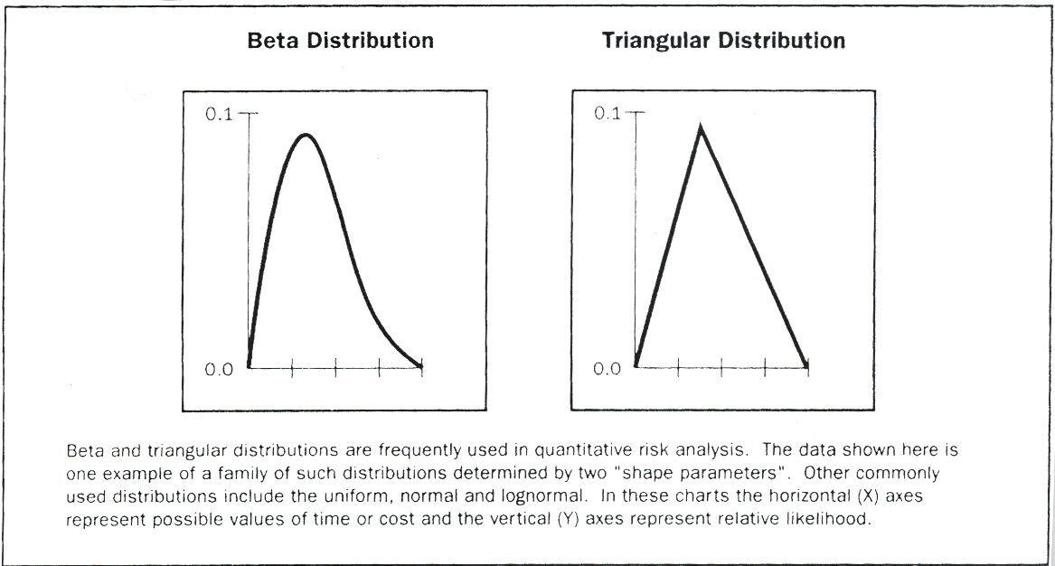
Figure 11-11. Examples of Commonly Used Probability Distributions

- Expert judgment. Subject matter experts internal or external to the organization, such as engineering or statistical experts, validate data and techniques.

- Quantitative Risk Analysis and Modeling Techniques
Commonly used techniques in Quantitative Risk Analysis include:

- Sensitivity analysis. Sensitivity analysis helps to determine which risks have the most potential impact on the project. It examines the extent to which the uncertainty of each project element affects the objective being examined when all other uncertain elements are held at their baseline values. One typical display of sensitivity analysis is the tornado diagram, which is useful for comparing relative importance of variables that have a high degree of uncertainty to those that are more stable.
- Expected monetary value analysis. Expected monetary value (EMV) analysis is a statistical concept that calculates the average outcome when the future includes scenarios that may or may not happen (i.e., analysis under uncertainty). The EMV of opportunities will generally be expressed as positive values, while those of risks will be negative. EMV is calculated by multiplying the value of each possible outcome by its probability of occurrence, and adding them together. A common use of this type of analysis is in decision tree analysis (Figure 11-12). Modeling and simulation are recommended for use in cost and schedule risk analysis, because they are more powerful and less subject to misuse than EMV analysis.
- Decision tree analysis. Decision tree analysis is usually structured using a decision tree diagram (Figure 11-12) that describes a situation under consideration, and the implications of each of the available choices and possible scenarios. It incorporates the cost of each available choice, the probabilities of each possible scenario, and the rewards of each alternative logical path. Solving the decision tree provides the EMV (or other measure of interest to the organization) for each alternative, when all the rewards and subsequent decisions are quantified.
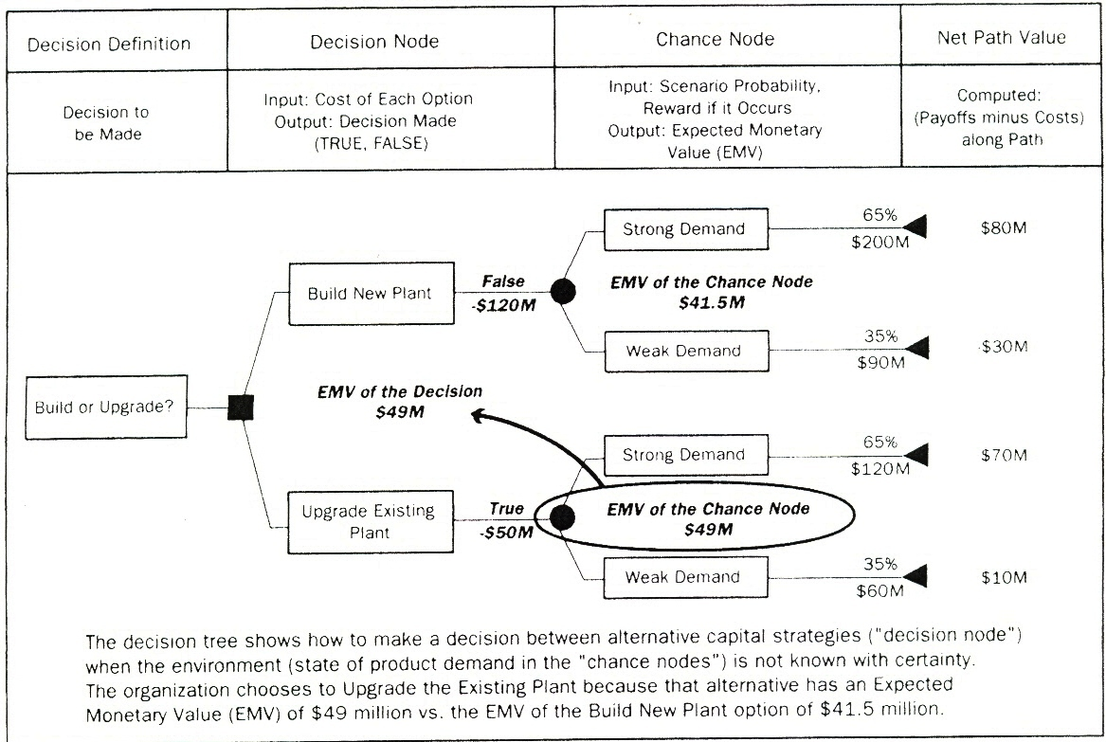

Figure 11-12. Decision Tree Diagram

- Modeling and simulation. A project simulation uses a model that translates the uncertainties specified at a detailed level of the project into their potential impact on project objectives. Simulations are typically performed using the Monte Carlo technique. In a simulation, the project model is computed many times (iterated), with the input values randomized from a probability distribution function (e.g., cost of project elements or duration of schedule activities) chosen for each iteration from the probability distributions of each variable. A probability distribution (e.g., total cost or completion date) is calculated.

For a cost risk analysis, a simulation can use the traditional project WBS (Section 5.3.3.2) or a cost breakdown structure as its model. For a schedule risk analysis, the precedence diagramming method (PDM) schedule is used (Section 6.2.2.1). A cost risk simulation is shown in Figure 11-13.

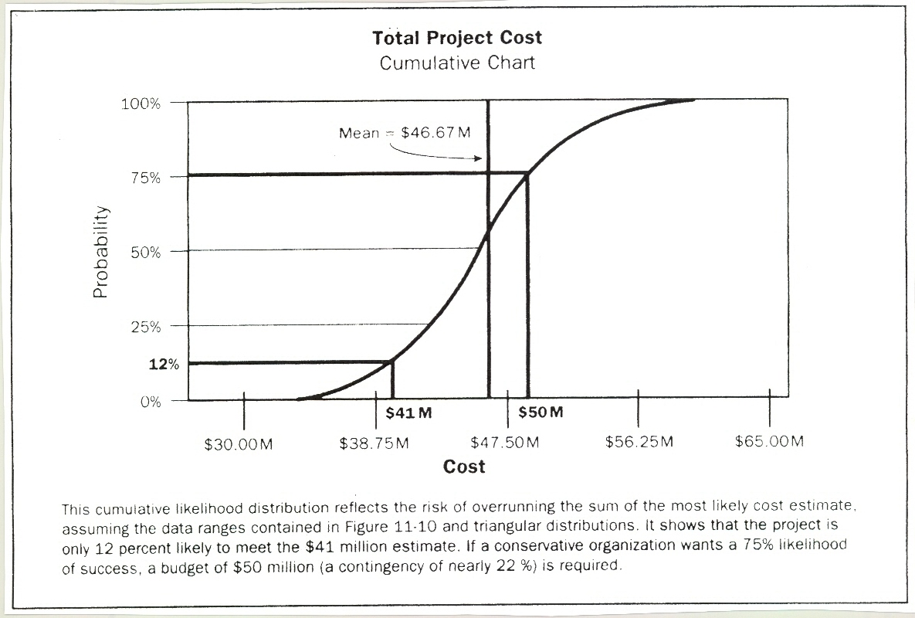
Figure 11-13. Cost Risk Simulation Results

11.4.3 Quantitative Risk Analysis: Outputs

- Risk Register (Updates)
The risk register is initiated in the Risk Identification process (Section 11.2) and updated in Qualitative Risk Analysis (Section 11.3). It is further updated in Quantitative Risk Analysis. The risk register is a component of the project management plan. Updates include the following main components:

- Probabilistic analysis of the project. Estimates are made of potential project schedule and cost outcomes, listing the possible completion dates and costs with their associated confidence levels. This output, typically expressed as a cumulative distribution, is used with stakeholder risk tolerances to permit quantification of the cost and time contingency reserves. Such contingency reserves are needed to bring the risk of overrunning stated project objectives to a level acceptable to the organization. For instance, in Figure 11-13, the cost contingency to the 75th percentile is $9 million, or about 22% versus the $41 million sum of the most likely estimates.
- Probability of achieving cost and time objectives. With the risks facing the project, the probability of achieving project objectives under the current plan can be estimated using quantitative risk analysis results. For instance, in Figure 11-13, the likelihood of achieving the cost estimate of $41 million (from Figure 11-10) is about 12%.
- Prioritized list of quantified risks. This list of risks includes those that pose the greatest threat or present the greatest opportunity to the project. These include the risks that require the greatest cost contingency and those that are most likely to influence the critical path.
- Trends in quantitative risk analysis results. As the analysis is repeated, a trend may become apparent that leads to conclusions affecting risk responses.

11.5 Risk Response Planning

Risk Response Planning is the process of developing options, and determining actions to enhance opportunities and reduce threats to the project's objectives. It follows the Qualitative Risk Analysis and Quantitative Risk Analysis processes. It includes the identification and assignment of one or more persons (the "risk response owner") to take responsibility for each agreed-to and funded risk response. Risk Response Planning addresses the risks by their priority, inserting resources and activities into the budget, schedule, and project management plan, as needed.

Planned risk responses must be appropriate to the significance of the risk, cost effective in meeting the challenge, timely, realistic within the project context, agreed upon by all parties involved, and owned by a responsible person. Selecting the best risk response from several options is often required.

The Risk Response Planning section presents commonly used approaches to planning responses to the risks. Risks include threats and opportunities that can affect project success, and responses are discussed for each.

INPUTS | Tools & Techniques | Outputs
- Risk management plan | - Strategies for negative risks or threats | - Risk register (updates)
- Risk register | - Strategies for positive risks or opportunities | - Project management plan (updates)
 | - Strategy for both threats and opportunities | - Risk related contractual agreements
 | - Contingent response strategy

Figure 11-14. Risk Response Planning: Inputs, Tools & Techniques, and Outputs

11.5.1 Risk Response Planning: Inputs
- Risk Management Plan
Important components of the risk management plan include roles and responsibilities, risk analysis definitions, risk thresholds for low, moderate, and high risks, and the time and budget required to conduct Project Risk Management.

Some components of the Risk Management Plan that are important inputs to Risk Response Planning may include risk thresholds for low, moderate, and high risks to help understand those risks for which responses are needed, assignment of personnel and scheduling and budgeting for risk response planning.

- Risk Register
The risk register is first developed in the Risk Identification process, and is updated during the Qualitative and Quantitative Risk Analysis processes. The Risk Response Planning process may have to refer back to identified risks, root causes of risks, lists of potential responses, risk owners, symptoms, and warning signs in developing risk responses.

Important inputs to Risk Response Planning include the relative rating or priority list of project risks, a list of risks requiring response in the near term, a list of risks for additional analysis and response, trends in qualitative risk analysis results, root causes, risks grouped by categories, and a watch list of low priority risks. The risk register is further updated during the Quantitative Risk Analysis process.

11.5.2 Risk Response Planning: Tools and Techniques
Several risk response strategies are available. The strategy or mix of strategies most likely to be effective should be selected for each risk. Risk analysis tools, such as decision tree analysis, can be used to choose the most appropriate response. Then specific actions are developed to implement that strategy. Primary and backup strategies may be selected. A fallback plan can be developed for implementation if the selected strategy turns out not to be fully effective, or if an accepted risk occurs. Often, a contingency reserve is allocated for time or cost. Finally, contingency plans can be developed, along with identification of the conditions that trigger their execution.

- Strategies for Negative Risks or Threats
Three strategies typically deal with threats or risks that may have negative impacts on project objectives if they occur. These strategies are to avoid, transfer, or mitigate:
- Avoid. Risk avoidance involves changing the project management plan to eliminate the threat posed by an adverse risk, to isolate the project objectives from the risk impact, or to relax the objective that is in jeopardy, such as extending the schedule or reducing scope. Some risks that arise early in the project can be avoided by clarifying requirements, obtaining information, improving communication, or acquiring expertise.
- Transfer. Risk transference requires shifting the negative impact of a threat, along with ownership of the response, to a third party. Transferring the risk simply' gives another party responsibility for its management; it does not eliminate it. Transferring liability for risk is most effective in dealing with financial risk exposure. Risk transference nearly always involves payment of a risk premium to a third party taking on the risk. Transference tools can be quite diverse and include, but are not limited to, the use of insurance, performance bonds, guarantees, etc. Contracts may be used to transfer liability for specified risks to another party. In many cases, use of a cost-type contract may transfer the cost risk to the buyer, while a fixed-price contract may transfer risk to the seller, if the project's design is stable.
- Mitigate. Risk mitigation implies a reduction in the probability and/or impact of an adverse risk event to an acceptable threshold. Taking early action to reduce the probability and/or impact of a risk occurring on the project is often more effective than trying to repair the damage after the risk has occurred. Adopting less complex processes, conducting more tests, or choosing a more stable supplier are examples of risk mitigation actions. Mitigation may require prototype development to reduce the risk of scaling up from bench-scale model of a process or product. Where it is not possible to reduce probability, a mitigation response might address the risk impact by targeting linkages that determine the severity. For example, designing redundancy into a subsystem may reduce the impact from a failure of the original component.

- Strategies for Positive Risks or Opportunities
Three responses are suggested to deal with risks with potentially positive impacts on project objectives. These strategies are to exploit, share, or enhance.

- Exploit. This strategy may be selected for risks with positive impacts where the organization wishes to ensure that the opportunity is realized. This strategy seeks to eliminate the uncertainty associated with a particular upside risk by making the opportunity definitely happen. Directly exploiting responses include assigning more talented resources to the project to reduce the time to completion, or to provide better quality than originally planned.
- Share. Sharing a positive risk involves allocating ownership to a third party who is best able to capture the opportunity for the benefit of the project. Examples of sharing actions include forming risk-sharing partnerships, teams, special-purpose companies, or joint ventures, which can be established with the express purpose of managing opportunities.
- Enhance. This strategy modifies the “size” of an opportunity be increasing probability and/or positive impacts, and by identifying and maximizing key drivers of these positive-impact risks. Seeking to facilitate or strengthen the cause of the opportunity, and proactively targeting and reinforcing its trigger conditions, might increase probability. Impact drivers can also be targeted, seeking to increase the project's susceptibility to the opportunity.

- Strategy for Both Threats and Opportunities
Acceptance: A strategy that is adopted because it is seldom possible to eliminate all risk from a project. This strategy indicates that the project team has decided not to change the project management plan to deal with a risk, or is unable to identify any other suitable response strategy. It may be adopted for either threats or opportunities. This strategy can be either passive or active. Passive acceptance requires no action, leaving the project team to deal with the threats or opportunities as they occur. The most common active acceptance strategy is to establish a contingency reserve, including amounts of time, money, or resources to handle known-or even sometimes potential, unknown-threats or opportunities.

- Contingent Response Strategy
Some responses are designed for use only if certain events occur. For some risks, it is appropriate for the project team to make a response plan that will only be executed under certain predefined conditions, is believed that there will be sufficient warning to implement the plan. Events that trigger the contingency response, such as missing intermediate milestones or gaining higher priority with a supplier, should be defined and tracked.

11.5.3 Risk Response Planning: Outputs
- Risk Register (Updates)
The risk register is developed in Risk Identification, and is updated during Qualitative Risk Analysis and Quantitative Risk Analysis. In the Risk Response Planning process, appropriate responses are chosen, agreed-upon, and included in the risk register. The risk register should be written to a level of detail that corresponds with the priority ranking and the planned response. Often, the high and moderate risks are addressed in detail. Risks judged to be of low priority are included in a watch list for periodic monitoring. Components of the risk register at this point can include:

- Identified risks, their descriptions, area(s) of the project (e.g., WBS element) affected, their causes (e.g., RBS element), and how they may affect project objectives
- Risk owners and assigned responsibilities
- Outputs from the Qualitative and Quantitative Risk Analysis processes, including prioritized lists of project risks and probabilistic analysis of the project
- Agreed-upon response strategies
- Specific actions to implement the chosen response strategy
- Symptoms and warning signs of risks' occurrence
- Budget and schedule activities required to implement the chosen responses
- Contingency reserves of time and cost designed to provide for stakeholders' risk tolerances
- Contingency plans and triggers that call for their execution
- Fallback plans for use as a reaction to a risk that has occurred, and the primary response proves to be inadequate
- Residual risks that are expected to remain after planned responses have been taken, as well as those that have been deliberately accepted
- Secondary risks that arise as a direct outcome of implementing a risk response
- Contingency reserves that are calculated based on the quantitative analysis of the project and the organization's risk thresholds.

- Project Management Plan (Updates)
The project management plan is updated as response activities are added after review and disposition through the Integrated Change Control process (Section 4.6). Integrated change control is applied in the Direct and Manage Project Execution process (Section 4.4) to ensure that agreed-upon actions are implemented and monitored as part of the ongoing project. Risk response strategies, once agreed to, must be fed back into the appropriate processes in other Knowledge Areas, including the project's budget and schedule.

- Risk-Related Contractual Agreements
Contractual agreements, such as agreements for insurance, services, and other items as appropriate, can be prepared to specify each party's responsibility for specific risks, should they occur.

11.6 Risk Monitoring and Control
Planned risk responses (Section 11.5) that are included in the project management plan are executed during the life cycle of the project, but the project work should be continuously monitored for new and changing risks.

Risk Monitoring and Control (Section 4.4) is the process of identifying, analyzing, and planning for newly arising risks, keeping track of the identified risks and those on the watch list, reanalyzing existing risks, monitoring trigger conditions for contingency plans, monitoring residual risks, and reviewing the execution of risk responses while evaluating their effectiveness. The Risk Monitoring and Control process applies techniques, such as variance and trend analysis, which require the use of performance data generated during project execution. Risk Monitoring and Control, as well as the other risk management processes, is an ongoing process for the life of the project. Other purposes of Risk Monitoring and Control are to determine if:
- Project assumptions are still valid
- Risk, as assessed, has changed from its prior state, with analysis of trends
- Proper risk management policies and procedures are being followed
- Contingency reserves of cost or schedule should be modified in line with the risks of the project.

Risk Monitoring and Control can involve choosing alternative strategies, executing a contingency or fallback plan, taking corrective action, and modifying the project management plan. The risk response owner reports periodically to the project manager on the effectiveness of the plan, any unanticipated effects, and any mid-course correction needed to handle the risk appropriately. Risk Monitoring and Control also includes updating the organizational process assets (Section 4.1.1.4), including project lessons-learned databases and risk management templates for the benefit of future projects.

INPUTS | Tools & Techniques | Outputs
- Risk management plan | - Risk reassessment | - Risk register (updates)
- Risk register | - Risk audits | - P Requested changes
- Approved change requests | - Variance and trend analysis | - Recommended corrective actions
- Work performance information | - Technical performance measurement | - Recommended preventive actions
- Performance reports | - Reserve analysis | - Organizational process assets (updates)
 | - Status meetings | - Project management plan(updates)
Figure 11-15. Risk Monitoring and Control: Inputs, Tools & Techniques, and Outputs

11.6.1 Risk Monitoring and Control: Inputs
- Risk Management Plan
This plan has key inputs that include the assignment of people, including the risk owners, time, and other resources to project risk management.

- Risk Register
The risk register has key inputs that include identified risks and risk owners, agreed-upon risk responses, specific implementation actions, symptoms and warning signs of risk, residual and secondary risks, a watch list of low priority risks, and the time and cost contingency reserves.

- Approved Change Requests
Approved change requests (Section 4.6.3.1) can include modifications such as work methods, contract terms, scope, and schedule. Approved changes can generate risks or changes in identified risks, and those changes need to be analyzed for any effects upon the risk register, risk response plan, or risk management plan. All changes should be formally documented. Any verbally discussed, but undocumented, changes should not be processed or implemented .

- Work Performance Information
Work performance information (Section 4.4.3.7), including project deliverables' status, corrective actions, and performance reports, are important inputs to Risk Monitoring and Control.

.5 Performance Reports
Performance reports (Section 10.3.3.1) provide information on project work performance, such as an analysis that may influence the risk management processes.

11.6.2 Risk Monitoring and Control: Tools and Techniques
- Risk Reassessment
Risk Monitoring and Control often requires identification of new risks and reassessment of risks, using the processes of this chapter as appropriate. Project risk reassessments should be regularly scheduled. Project Risk Management should be an agenda item at project team status meetings. The amount and detail of repetition that is appropriate depends on how the project progresses relative to its objectives. For instance, if a risk emerges that was not anticipated in the risk register or included on the watch list, or if its impact on objectives is different from what was expected, the planned response may not be adequate. It will then be necessary to perform additional response planning to control the risk.

- Risk Audits
Risk audits examine and document the effectiveness of risk responses in dealing with identified risks and their root causes, as well as the effectiveness of the risk management process.

- Variance and Trend Analysis
Trends in the project's execution should be reviewed using performance data. Earned value analysis (Section 7.3.2.4) and other methods of project variance and trend analysis may be used for monitoring overall project performance. Outcomes from these analyses may forecast potential deviation of the project at completion from cost and schedule targets. Deviation from the baseline plan may indicate the potential impact of threats or opportunities.

- Technical Performance Measurement
Technical performance measurement compares technical accomplishments during project execution to the project management plan's schedule of technical achievement. Deviation, such as demonstrating more or less functionality than planned at a milestone, can help to forecast the degree of success in achieving the project's scope.

- Reserve Analysis
Throughout execution of the project, some risks may occur, with positive or negative impacts on budget or schedule contingency reserves (Section 11.5.2.4). Reserve analysis compares the amount of the contingency reserves remaining to the amount of risk remaining at any time in the project, in order to determine if the remaining reserve is adequate.

- Status Meetings
Project risk management can be an agenda item at periodic status meetings. That item may take no time or a long time, depending on the risks that have been identified, their priority, and difficulty of response. Risk management becomes easier the more often it is practiced, and frequent discussions about risk make talking about risks, particularly threats, easier and more accurate.

11.6.3 Risk Monitoring and Control: Outputs
- Risk Register (Updates)
An updated risk register contains:
- Outcomes of risk reassessments, risk audits, and periodic risk reviews. These outcomes may include updates to probability, impact, priority, response plans, ownership, and other elements of the risk register. Outcomes can also include closing risks that are no longer applicable.
- The actual outcomes of the project's risks and of risk responses that can help project managers plan for risk throughout the organization, as well as on future projects. This completes the record of risk management on the project, is an input to the Close Project process (Section 4.7), and becomes part of the project closure documents.

- Requested Changes
Implementing contingency plans or workarounds frequently results in a, requirement to change the project management plan to respond to risks. Requested changes are prepared and submitted to the Integrated Change Control process (Section 4.6) as an output of the Risk Monitoring and Control process. Approved change requests are issued and become inputs to the Direct and Manage Project Execution process (Section 4.4) and to the Risk Monitoring and Control process.

- Recommended Corrective Actions
Recommended corrective actions include contingency plans and workaround plans. The latter are responses that were not initially planned, but are required to deal with emerging risks that were previously unidentified or accepted passively. Workarounds should be properly documented and included in both the Direct an Manage Project Execution (Section 4.4) and Monitor and Control Project Work (Section 4.5) processes. Recommended corrective actions are inputs to the Integrated Change Control process (Section 4.6).

- Recommended Preventive Actions
Recommended preventive actions are used to bring the project into compliance with the project management plan.

- Organizational Process Assets (Updates)
The six Project Risk Management processes produce information that can be used for future projects, and should be captured in the organizational process assets (Section 4.1.1.4). The templates for the risk management plan, including the probability and impact matrix, and risk register, can be updated at project closure. Risks can be documented and the RBS updated. Lessons learned from the project risk management activities can contribute to the lessons learned knowledge database of the organization. Data on the actual costs and durations of project activities can be added to the organization's databases. The final versions of the risk register and the risk management plan templates, checklists, and RBSs are included.

- Project Management Plan (Updates)
If the approved change requests have an effect on the risk management processes, then the corresponding component documents of the project management plan are revised and reissued to reflect the approved changes.

