Online Library System
Use Case Specification: <Use-Case Name>

Version <1.0>

Revision History
Date | Version | Description | Author
December 3, 2006 | 1.0 | Defining and Explaining Member Registry Use-Case | Author

Table of Contents
1. Use Case Name 2
1.1 Brief Description 2
2. Flow of Events 2
2.1 Basic Flow 2
3. Special Requirements 2
4. Pre-Conditions 2
4.1 Online Library Catalog Facility 2
5. Post-Conditions 2
5.1 Accecc to Member's Area 2
6. Extension Points 2
6.1 “Not a Student” Warning 2

Use Case Specification: <Use-Case Name>

Member Registry

Brief Description
This use-case defines the steps of registering a student as a member. Students usually can easily register by providing their information.

Flow of Events

Basic Flow
This use case starts when the user click register button on library’s main page. Then a form to enter personal details becomes available to fill up by the user. Web page has sufficient explanations for the required info.
Web page specifically explains why required information is needed. User enters the name, address, and billing information like credit card details.
Flow-chart;
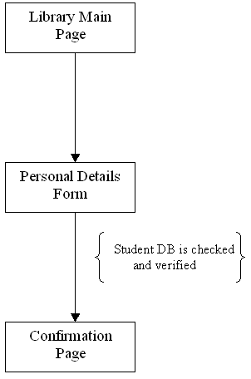

Special Requirements
The special requirement is that user has be an enrolled student for the given semester. Since the user’s name will be matched with the school’s DB. For that reason it should in DB, otherwise registration will fail. Examples of special requirements include computer’s browser’s version number. Computer should also have Internet connectivity.

Pre-Conditions
4.1 Online Library Catalog Facility
Since this system is providing online capability of reserving, checking-out, and enrollment for the user, the library should have Online Library Catalog Facility.
Although it is a special requirement, it should be considered as a pre-condition too; in order to able to get registered student has to be enrolled at the given term.

Post-Conditions
After a successful attempt to enroll in the system, there is one very important condition. User have access to see his/her personal details, and account info about barrowed items.

Access to Member’s Area
After getting enrolled, student can view his/her details, search items, reserve item, and even extend the due dates of barrowed items. All these functionalities were made possible by having student’s details in a Data Base Management System.

Extension Points
This use case is assuming that student has record in school DB. If there is no entry matching with the info that student provided, system should have some warning message.

“Not a Student” Warning
This points come just after when student provide his/her info and clicked to get enrolled but there is no matching entry for that given name. In this case web site should have some kind of warning message, it could be either a pop-up message or it could be static web page. In both cases, user should be forwarded or directed to main page to have him/her try entering details again.
Flow-chart including this exit-point;
