Version Control With TortoiseHG (Mercurial) and Bitbucket
The Initial Setup

- Create Bitbucket Account
- Log on to https://bitbucket.org

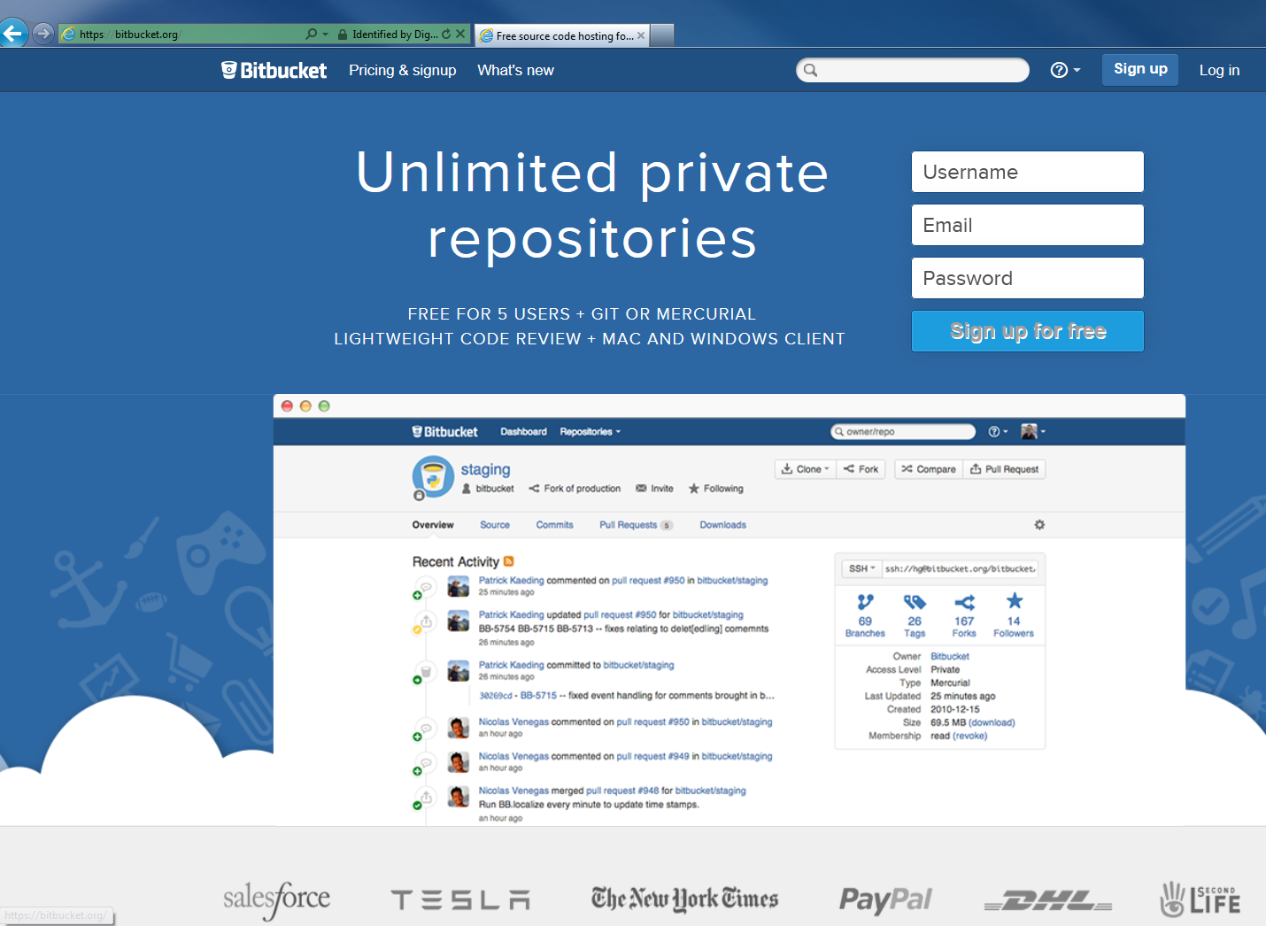

- Each member in the team will need an individual account
- For team, create a team account as follows and add the team members
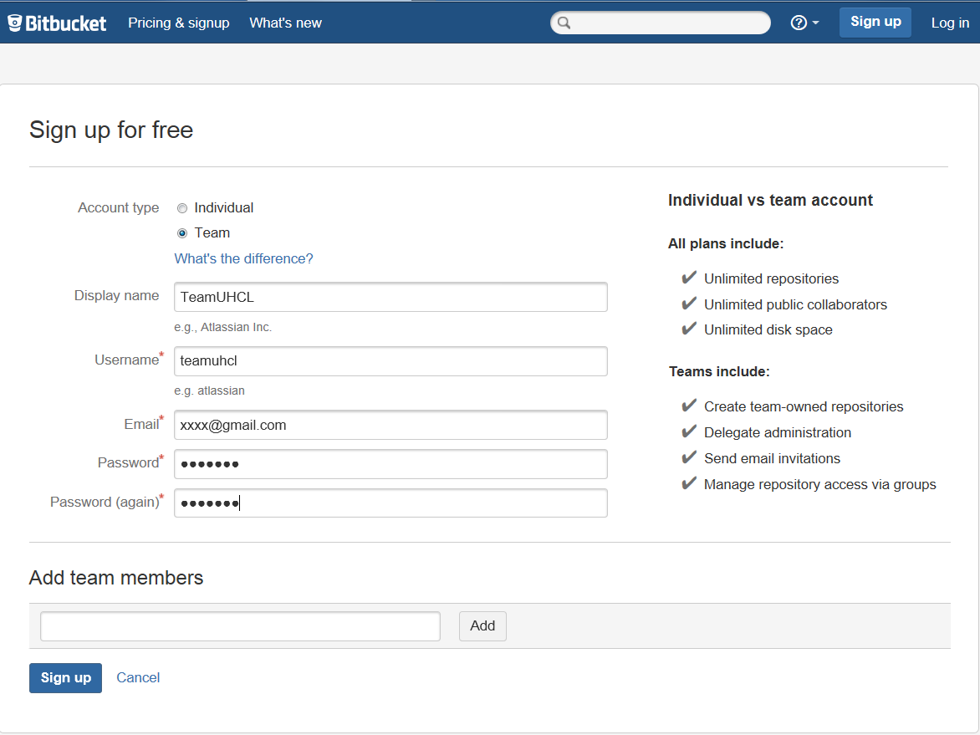

- Create a team repository, enter the required details like the name, type and language
Choose Mercurial for Repository Type.

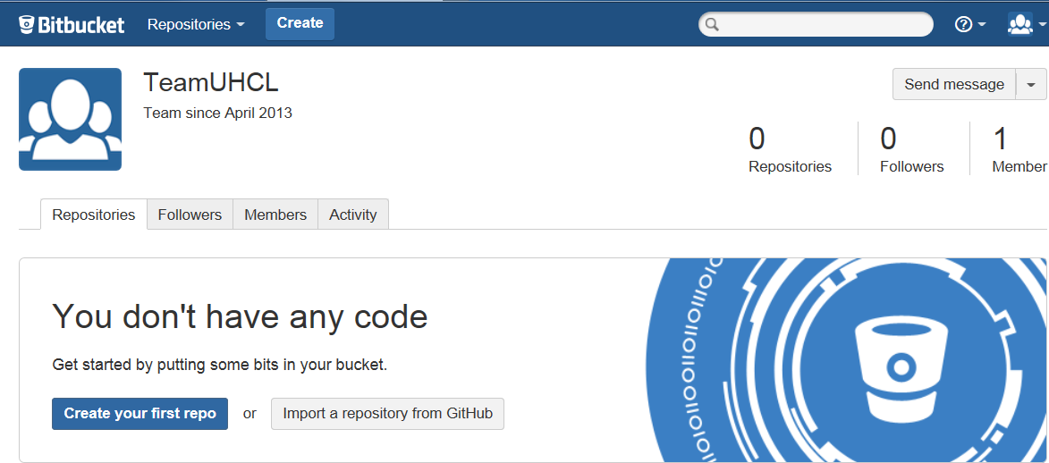

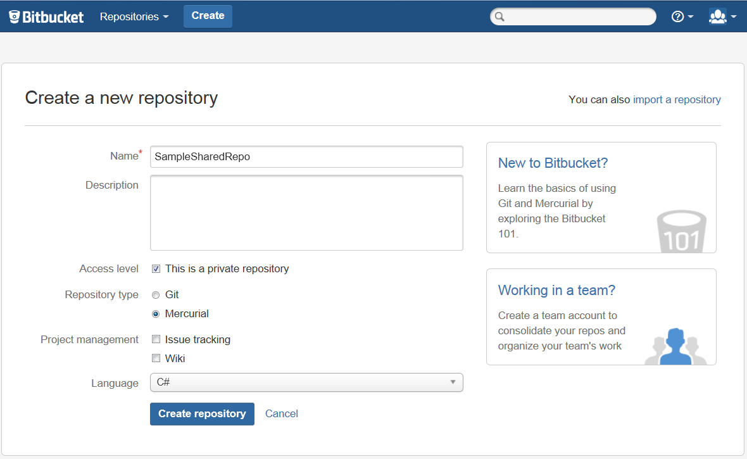

- Download and install TortoiseHg from http://tortoisehg.bitbucket.org/, if not already present.

- Create the initial application set up for the team. Here a sample asp.net web application is shown

- Choose an appropriate folder for the application and create the project in this folder.

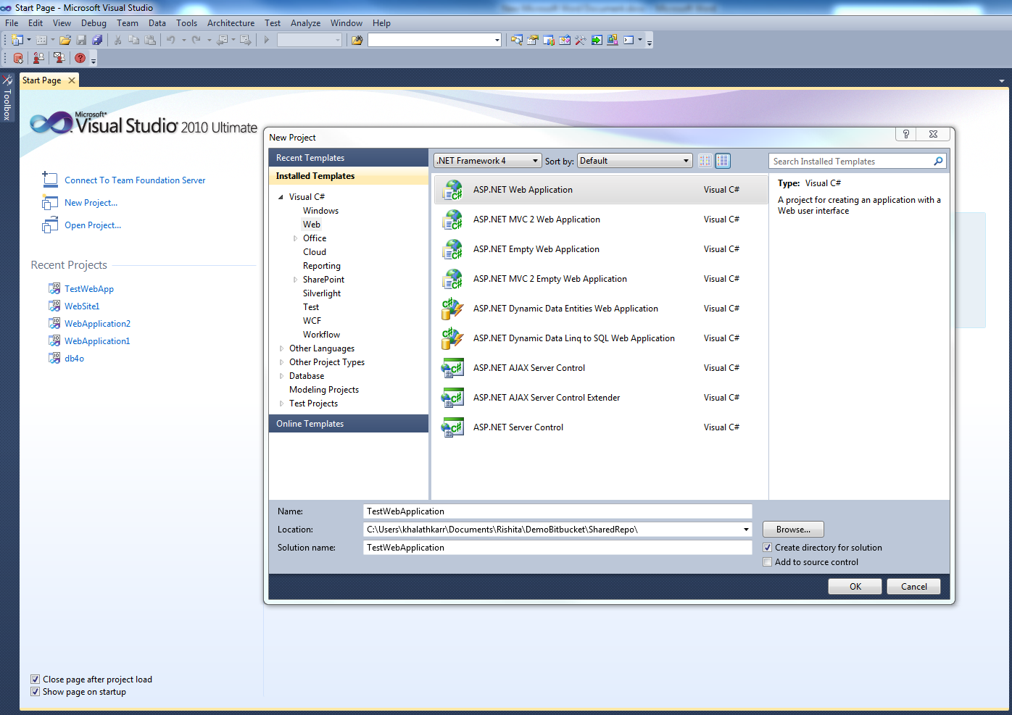

- After the project is created, browse to the folder where it is created.
- Right click ->TortoiseHg->Create Repository Here

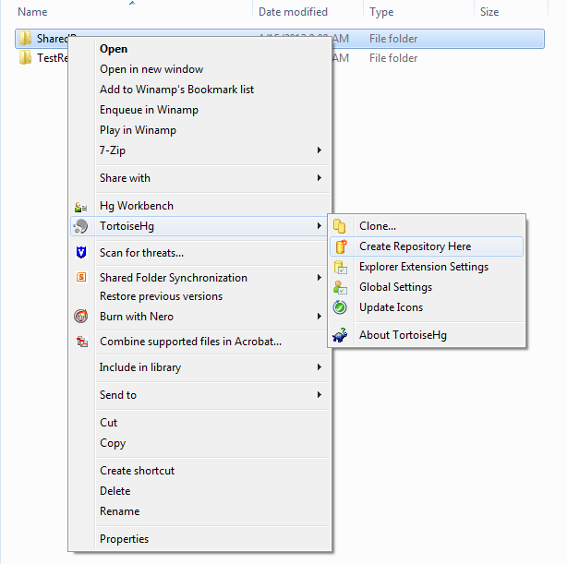

- Open this folder Right click ->Hg Workbench. Tortoise Hg workbench opens. Select the current repository and click on commit
- As this is the initial commit, generally all files are selected

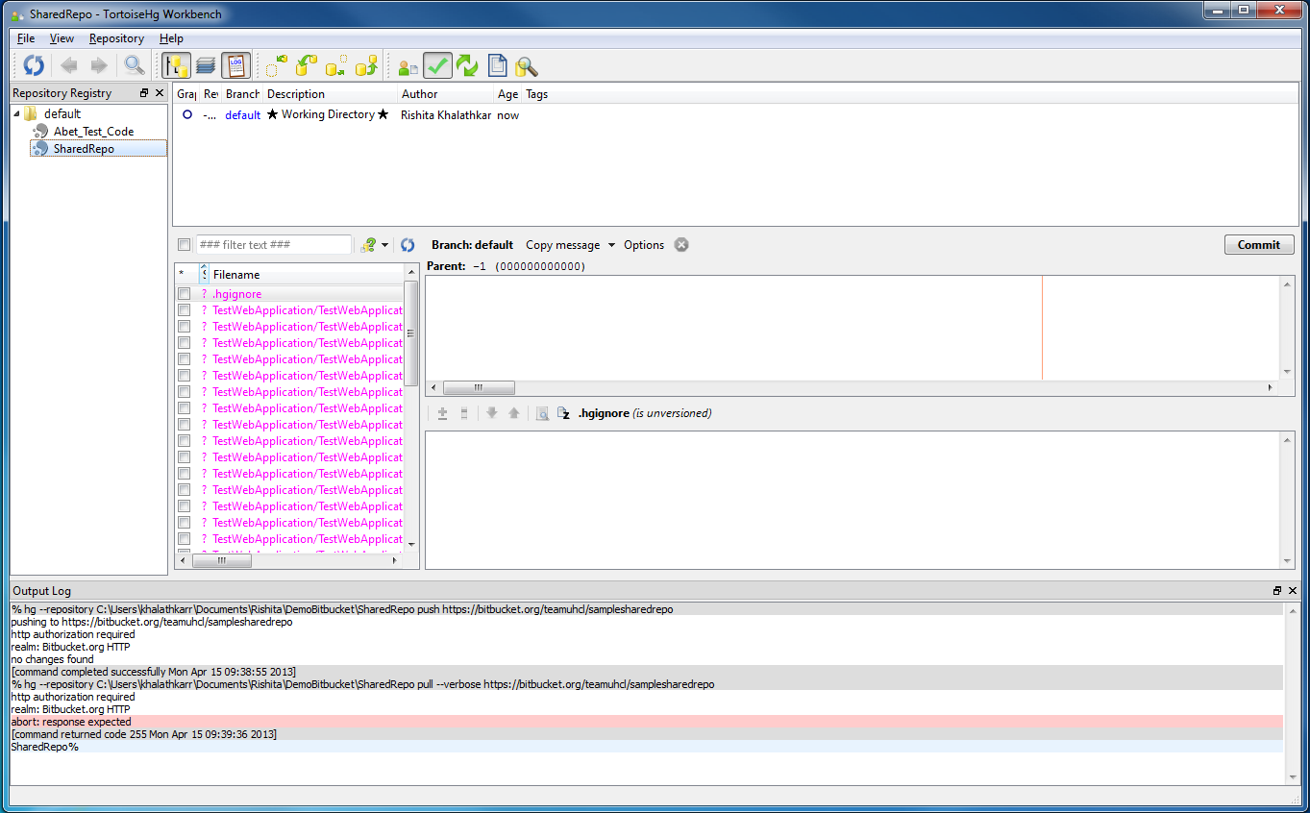
Enter an appropriate comment and commit

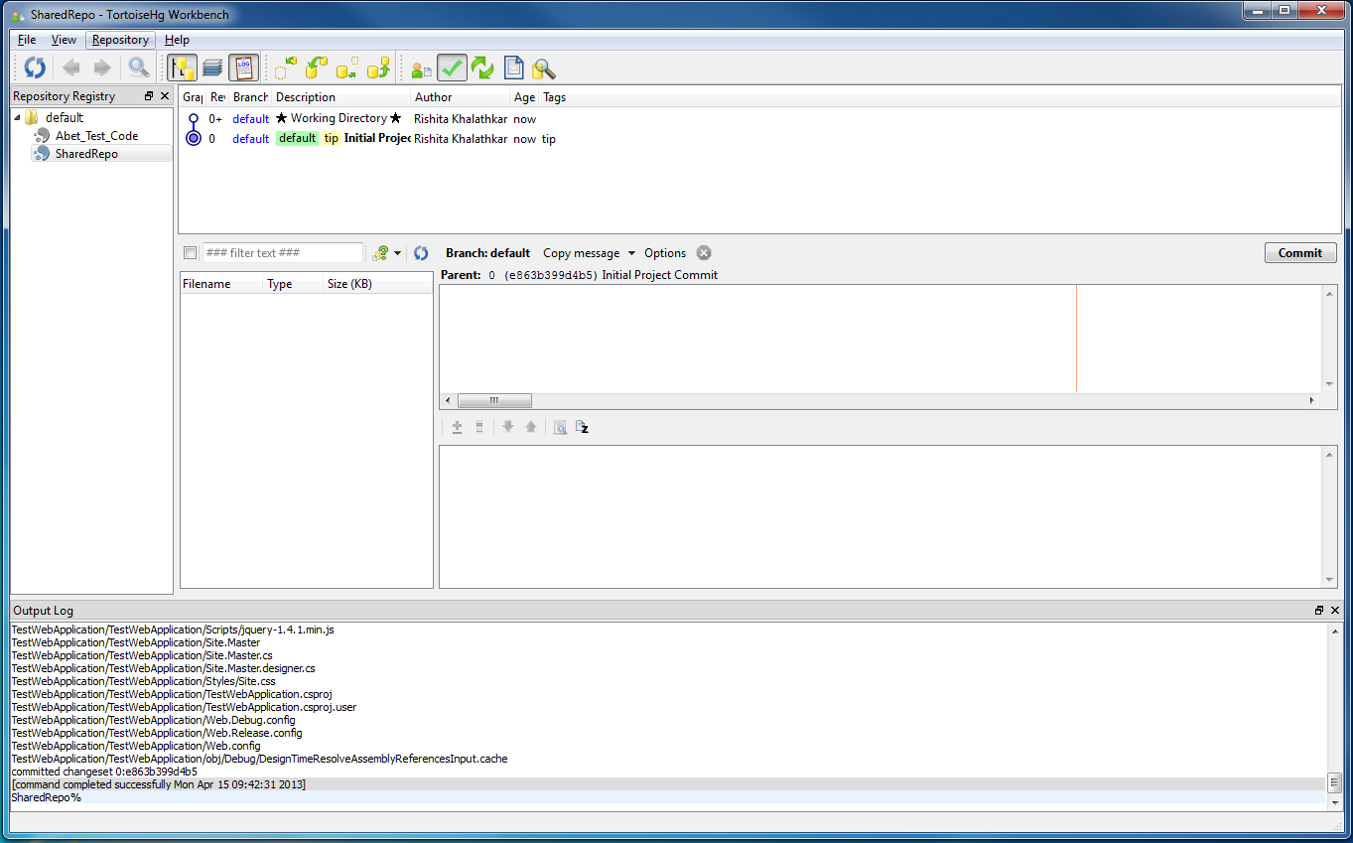

- Now click on Sync
Remote repository options are shown
Choose https and enter the online Bitbucket repository path here and give a suitable name to this path.

- Push changes to the online repository , username and password will be prompted. Only the users added to this team project are allowed
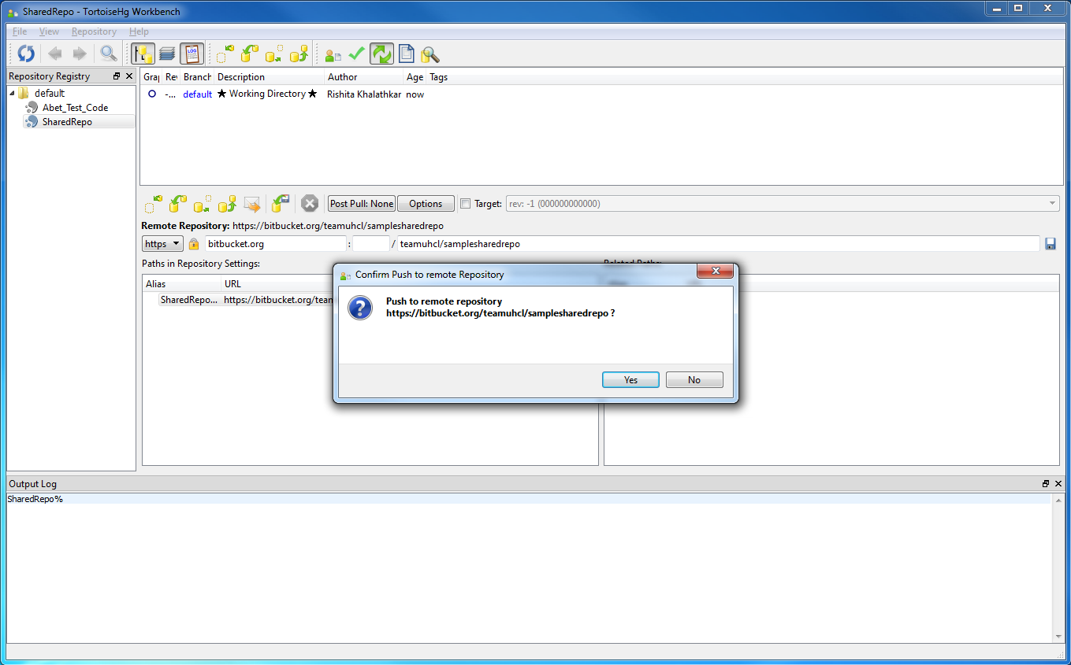

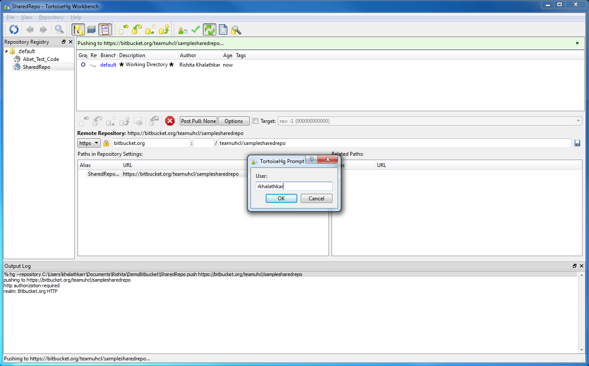

- After, this has been successful; the commit can be seen on the Bitbucket repository page.

Updating the local repository without making any changes on your end

- The user, who needs to clone this remote repository, creates a folder on his local machine.
The local machine should have Tortoise Hg installed.

- On the folder right click->Tortoise Hg -> Clone…

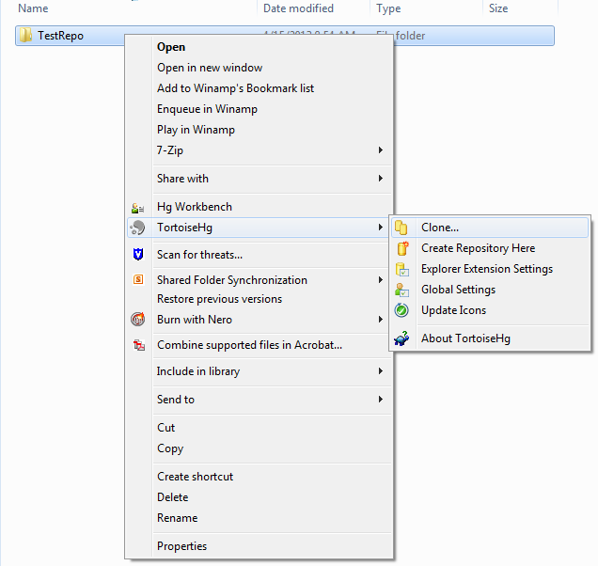
- Enter the source path as the online Bitbucket repository path.
Destination is the current folder

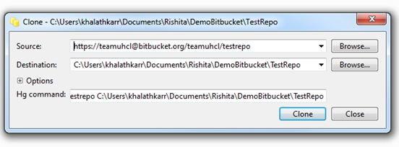

- Enter team password

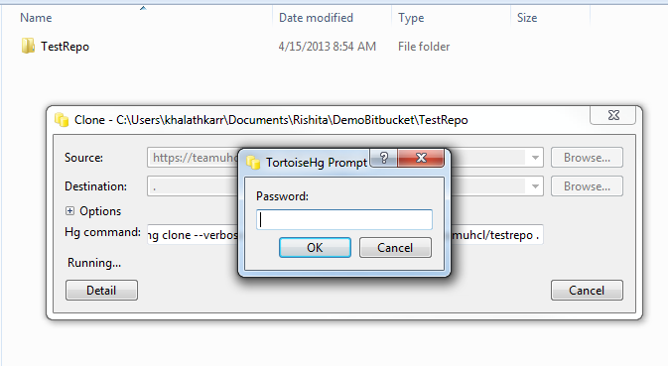

- All the files from remote server will be now downloaded to the folder

Version Control With TortoiseHG (Mercurial) and Bitbucket
Updating the repository after adding files/making changes

- Once the files are downloaded from remote repository, changes can be made or new files can be added
- Change files and save it.

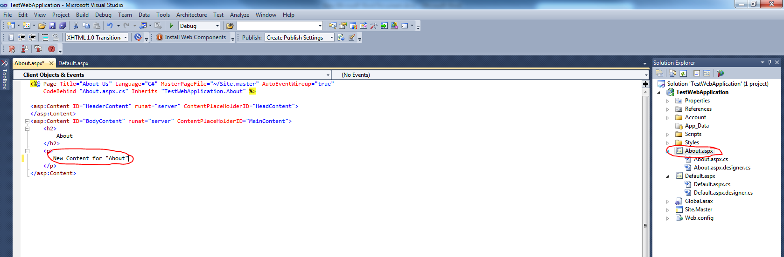

- Open the tortoise Hg workbench. Select the current repository.
- Click commit. The modified files are displayed. Select the required files enter an appropriate comment and commit.

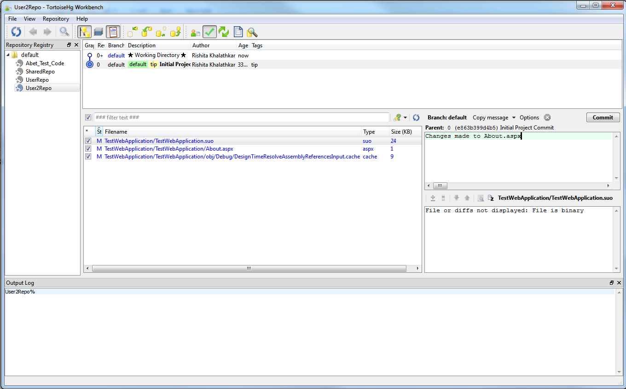

- Now pull changes from remote repository

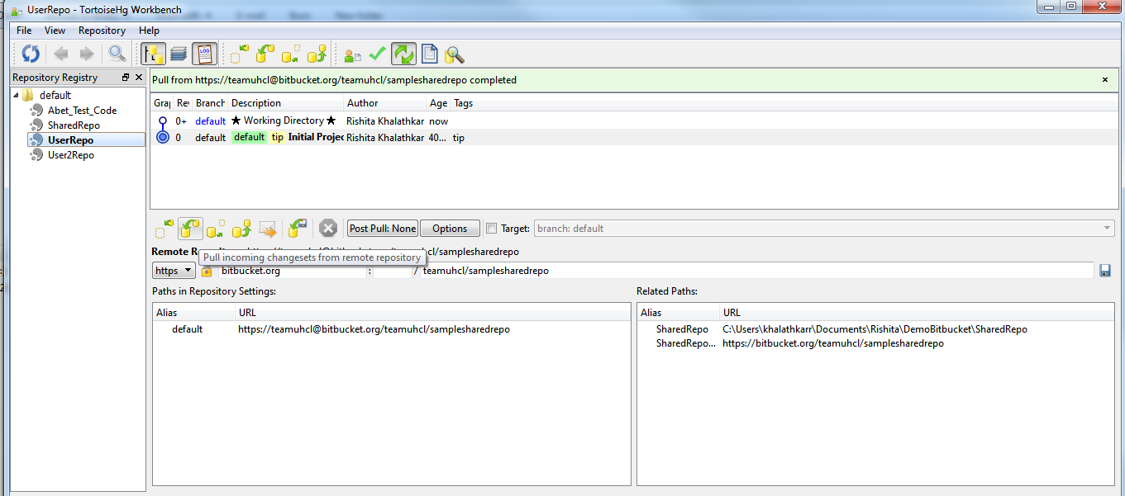
All the changes will be pulled.
Resolving conflicts
- On this pulled version, merge changes with local and commit the appropriate one.

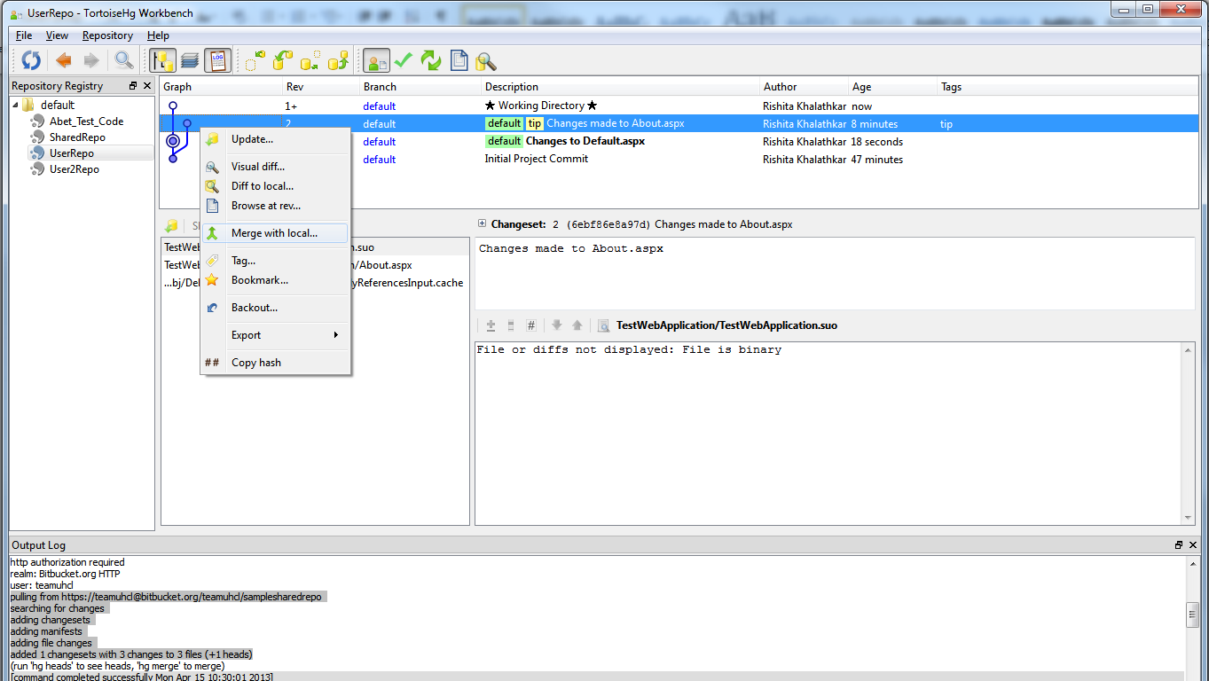

- At this point, the local version is in sync with the remote version
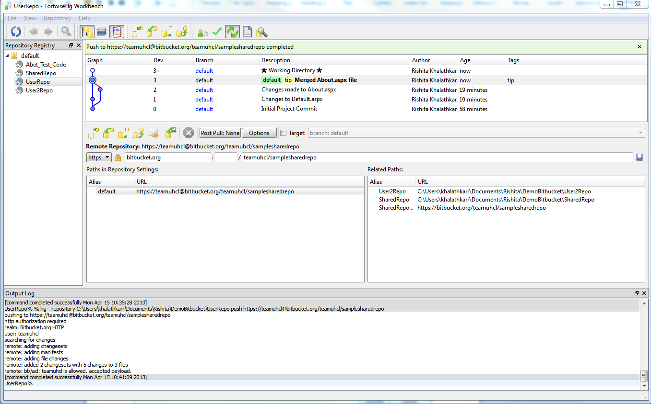
- Now, the local changes need to be pushed to the server.

- Now push changes to repository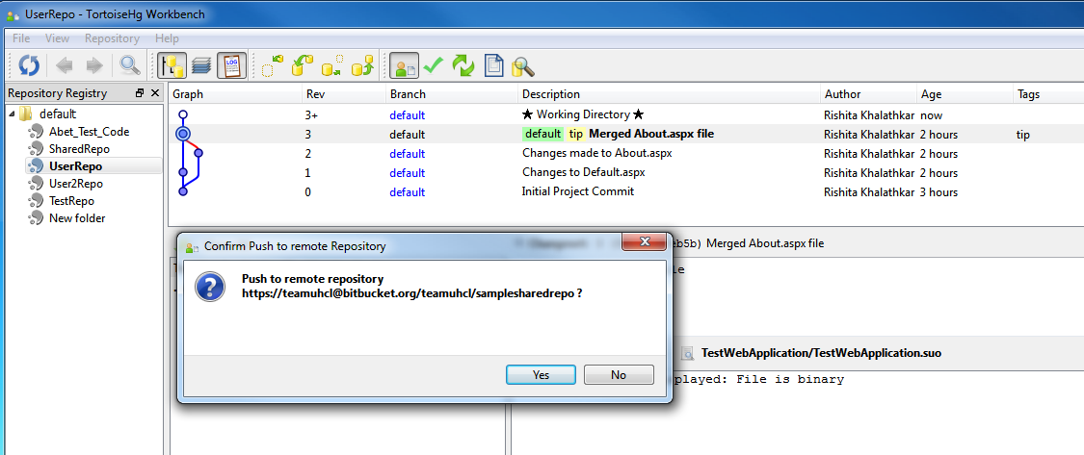

- . Once the push is successful, all the changes will be seen in the BitBucket repository page.

