THESIS PROPOSAL

WIRELESS LAN SECURITY

Committee Members:
Dr Andrew Yang
Dr Sadegh Davari

Dr Hisham Al-Mubaid

Submitted By
Yasir Zahur

SCHOOL OF SCIENCE AND COMPUTER ENGINEERING
UNIVERSITY OF HOUSTON – CLEAR LAKE
1 – INTRODUCTION
This thesis will study the security issues of wireless LANs (WLANs), their vulnerability, and alternative solutions. The proposed research plan includes experiments on studying the security and performance aspects of each of the alternative solutions. Appendix A contains a collection of technical terms related to wireless LANs and related technology, and their respective definitions.
The rest of the proposal is composed of the following sections:
- An introduction to WLAN (this section): types of WLANs, standards, and security features
- Definition of the research problem
- Alternative solutions to the problem: IEEE 802.1x, VPN (Virtual Private Networks), LEAP (Lightweight Extensible Authentication Protocol), and SSL (Secure Socket Layer)
- Setup of the test beds and configuration of the experiments
- Research plan and timelines

  - WIRELESS LOCAL AREA NETWORKS (WLANS)

A wireless LAN (WLAN) is analogous to a wired LAN but radio waves being the transport medium instead of traditional wired structures. This allows the users to move around in a limited area while being still connected to the network. Thus, WLANS combine data connectivity with user mobility, and, through simplified configuration, enable movable LANs [1]. In other words WLANS provide all the functionality of wired LANs, but without the physical constraints of the wire itself.

Generally a WLAN (in Infrastructure mode, see below) consists of a central connection point called the Access Point (AP). It is analogous to a hub or a switch in traditional star topology based wired local area networks. The Access Point transmits the data between different nodes of a wireless local area network and in most cases serves as the only link between the WLAN and the wired LAN. A typical Access Point can handle a handsome amount of users within a radius of about 300 feet. The wireless nodes, also called clients of a WLAN usually consist of Desktop PCs, Laptops or PDAs equipped with wireless interface cards.

1.2- Types of Wireless Networks
The 1999 version of the 802.11 standard [2] defines following three types of wireless networks:

- Independent Basic Service Set (IBSS)
IBSS (commonly referred to as Ad Hoc Network) is logically comparable to a Peer-to-Peer network in case of a wired LAN as shown in Fig.1. In case of IBSS different end nodes communicate without any Access Point and thus without any connection to a wired network. It is used to quickly set up a wireless network (to avoid the hidden node problem) such as for a group meeting or at a convention center or at an airport, etc.
AP
  Fig.1 Ad-hoc Mode | 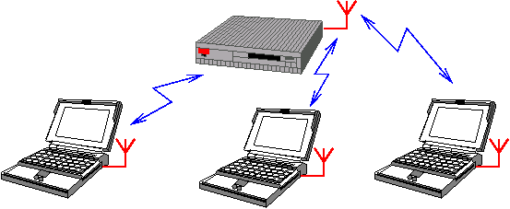  Fig.2 Infrastructure Mode

B. Basic Service Set (BSS)
BSS (commonly referred to as an Infrastructure Network) consists of a single Access Point as shown in Fig.2. All the communication between any two nodes has to pass through the AP. The coverage area is greatly increased as compared to an IBSS.

C. Extended Service Set (ESS)
An ESS consists of multiple BSSs each having a single Access Point. Access Point in each BSS is connected to a distribution system that is usually a Wired Ethernet Network.

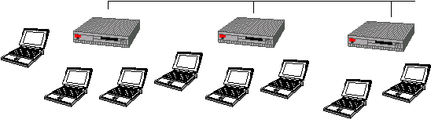

Fig.3 Extended Service Set (ESS)

1.3- Wireless Networking Standards [3]
Institute of Electrical and Electronics Engineers (IEEE) has specified various WLAN standards. Some important standards in the context of this thesis are summarized below in Table 1:

Standard | Description | Approved
IEEE 802.11 | Data rates up to 2Mbps in 2.4-GHz ISM band | July 1997
IEEE 802.11a | Data rates up to 54Mbps in 5-GHz UNII band | Sept 1999. End user products began shipping in early 2002
IEEE 802.11b | Data rates up to 11Mbps in 2.4-GHz ISM band | Sept 1999. End user products began shipping in early 2000

Table 1. IEEE WLAN Standards

1.3.1- IEEE 802.11b SECURITY FEATURES
The security features provided in 802.11b standard [2] are as follows:

A. SSID – Service Set Identifier
SSID acts as a WLAN identifier. Thus all devices trying to connect to a particular WLAN must be configured with the same SSID. It is added to the header of each packet sent over the WLAN (i.e. a BSS) and verified by an Access Point. A client device cannot communicate with an Access Point unless it is configured with the same SSID as the Access Point.

B. WEP - Wired Equivalent Privacy
According to the 802.11 standard, Wired Equivalent Privacy (WEP) was intended to provide “confidentiality that is subjectively equivalent to the confidentiality of a wired local area network (LAN) medium that does not employ cryptographic techniques to enhance privacy” [4].

IEEE specifications for wired LANs do not include data encryption as a requirement. This is because approximately all of these LANs are secured by physical means such as walled structures and controlled entrance to building etc. However no such physical boundaries can be provided in case of WLANs thus justifying the need for an encryption mechanism.

WEP provides for Symmetric Encryption using the WEP key. Each node has to be manually configured with the same WEP key. The sending station encrypts the message using the WEP key while the receiving station decrypts the message using the same WEP key. WEP uses the RC4 stream cipher.

C. MAC Address Filters
In this case, the Access Point is configured to accept association and connection requests from only those nodes whose MAC addresses are registered with the Access Point. This scheme provides an additional security layer.

2 - Problem Definition
Ubiquitous network access without wires is the main attraction underlying wireless network deployment. Although this seems as enough attraction, there exists other side of the picture. Before going All-Wireless, organizations should first understand how wireless networks could be vulnerable to several types of intrusion methods.

- INVASION & RESOURCE STEALING: Resources of a network can be various devices like printers and Internet access etc. First the attacker will try to determine the access parameters for that particular network. For example if network uses MAC Address based filtering of clients, all an intruder has to do is to determine MAC address and assigned IP address for a particular client. The intruder will wait till that valid client goes off the network and then he starts using the network and its resources while appearing as a valid user.

- TRAFFIC REDIRECTION: An intruder can change the route of the traffic and thus packets destined for a particular computer can be redirected to the attacking station. For example ARP tables (which contain MAC Address to IP Address Mapping) in switches of a wired network can be manipulated in such a way that packets for a particular wired station can be re-routed to the attacking station.

- DENIAL OF SERVICE (DOS): Two types of DOS attacks against a WLAN can exist. In the first case, the intruder tries to bring the network to its knees by causing excessive interference. An example could be excessive radio interference caused by 2.4 GHz cordless phones or other wireless devices operating at 2.4GHz frequency. A more focused DOS attack would be when an attacking station sends 802.11 dissociate message or an 802.1x EAPOL-logoff message (captured previously) to the target station and effectively disconnects it.

- ROUGE ACCESS POINT: A rogue Access Point is one that is installed by an attacker (usually in public areas like shared office space, airports etc) to accept traffic from wireless clients to whom it appears as a valid Authenticator. Packets thus captured can be used to extract sensitive information or can be used for further attacks before finally being re-inserted into the proper network

These concerns relate to wireless networks in general. The security concerns raised specifically against IEEE 802.11b networks [4] are as following.

- MAC Address Authentication: Such sort of authentication establishes the identity of the physical machine, not its human user. Thus an attacker who manages to steal a laptop with a registered MAC address will appear to the network as a legitimate user.

- ONE-WAY Authentication: WEP authentication is client centered or one-way only. This means that the client has to prove its identity to the Access Point but not vice versa. Thus a rogue Access Point will successfully authenticate the client station and then subsequently will be able to capture all the packets send by that station through it.

- Static WEP Keys: There is no concept of dynamic or per-session WEP keys in 802.11b specification. Moreover the same WEP key has to be manually entered at all the stations in the WLAN.

- SSID: Since SSID is usually provided in the message header and is transmitted in clear text format, it provides very little security. It is more of a network identifier than a security feature

- WEP KEY VULNERABILITY: WEP key based encryption was included to provide same level of data confidentiality in wireless networks as exists in typical wired networks. However a lot of concerns were raised later regarding the usefulness of WEP. The IEEE 802.11 design community blames 40-bit RC4 keys for this and recommends using 104- or 128-bit RC4 keys instead. Although using larger key size does increase the work of an intruder, it does not provide completely secure solution. Many recent research results have proved this notion [5]. According to these research publications the vulnerability of WEP roots from its initialization vector and not from its smaller key size

This thesis will try to address in depth the security limitations of WEP included in IEEE 802.11b specifications. To combat the WEP vulnerability for WLAN security, I plan to investigate the following solutions: IEEE 802.1x, VPN (Virtual Private Network), Cisco LEAP (Light Weight Authentication Protocol), and SSL (Secure Socket Layer). These alternative approaches will be studied and tested for their respective security strength and performance overhead.

3 - ALTERNATE SOLUTIONS

3.1- IEEE 802.1x
IEEE 802.1x is a port based authentication protocol. There are three different types of entities in a typical 802.1x network including a supplicant, an authenticator and an authentication server. When applied to 802.11b LANs, the 802.1X specification includes two main features [6]

- Logical Ports: Since, unlike wired networks, wireless stations are not connected to the network by physical means, they must have some sort of association relation with an Access Point in order to use the WLAN. This association is established by allowing the clients and Access Point to know each other’s MAC address. This combination of MAC address of Access Point and the station acts as a logical port. This then acts as a destination address in EAPOL protocol exchanges. EAPOL standard is defined for sending EAP messages over IEEE 802.11 based links. EAP message exchanges using EAPOL occurs at Data Link layer i.e. only MAC Addresses are involved. Higher-level protocols like IP have not been instantiated at this stage. EAPOL Frame format is shown in Fig: 4

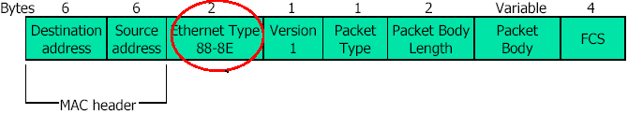
2-byte Type code assigned to EAPOL
Fig.4 EAPOL Frame Format

- Key Management: IEEE 802.1x specifications do not emphasize on using WEP key for encryption. This is because key information is passed from Access Point to a station using EAPOL-Key message. Thus keys are generated dynamically, per-session basis

Supplicant authenticates with the Authentication Server by using EAPOL to communicate with the Access Point. Messages are exchanged between Supplicant and Authenticator to establish Supplicant’s identity. The Authenticator then transfers Supplicant’s information to the Authentication Server using RADIUS. Authentication Server instantiates authentication mechanism by issuing a challenge message. All communication between Authentication Server and Supplicant passes through Authenticator using EAP over LAN (i.e. EAPOL) and EAP over RADIUS accordingly. This creates an end-to-end EAP conversation between Supplicant and Authentication Server. Once Authentication Server authenticates the Supplicant, the Authenticator delivers key parameters (and not the actual key) to the Supplicant. Typical configuration of WLAN using IEEE 802.1x is shown in Fig.5.

Supplicant Authenticator Authentication Server
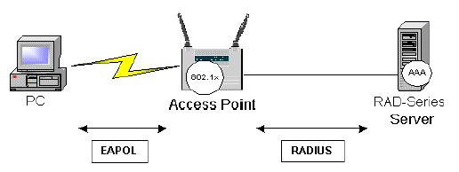
Fig.5 IEEE 802.1x in 802.11 WLANs

3.1.1- Association & EAP Authentication Procedure
IEEE 802.1X specifies two distinct ports. The first port is uncontrolled and allows only authentication messages (EAP messages) to be exchanged. Second port is controlled and allows the exchange of frames only if the port is authorized.

3.1.2- Advantages
- Dynamic Session Key Management: 802.1x allows dynamic session key encryption.
- Open Standards Based: 802.1x leverages existing standards, EAP and RADIUS.
- Centralized User Administration: Since 802.1x supports RADIUS, authentication, authorization and accounting are centralized.
- Low Overhead; 802.1x does not involve encapsulation, so it adds no per-packet overhead.
- User Based Identification

3.2- VIRTUAL PRIVATE NETWORK (VPN)
VPN technology provides the means to securely transmit data between two network devices over an insecure data transport medium [7]. VPN technology has been used successfully in wired networks especially when using Internet as a physical medium. This success of VPN in wired networks and the inherent security limitations of wireless networks have prompted developers and administrators to deploy it in case of wireless networks

3.2.1- Need for VPN in Wireless Networks
Wireless networking is inherently more vulnerable and less secure than wired networking. In order to come up with a security solution for wireless networks, we first want to emphasize two important aspects of wired networks in terms of their security:

- There is no specification of any encryption standard to be implemented in case of wired LANs. This is because the wired networks (i.e., the cabling, the routers, etc.) are usually within the enclosed physical structure of an organization.

- Even if the medium used is insecure (e.g., the Internet), to implement security, emphasis is laid on Network Layer and above instead of Physical Layer. For example, some form of user authentication or Internet Firewall can be implemented. This is because in case of Internet, there is no one physical dedicated link between the two end stations. Thus Physical Layer cannot be relied upon providing substantial security.

Wireless network cannot be confined within a physical boundary. Moreover argument no.2 above for wired networks could be logically applied to wireless networks also. Thus instead of encrypting the data using WEP Key, a secure end-to-end connection (or tunnel) can be implemented which necessitates the use of VPN Technology.

3.2.2- Overview of VPN

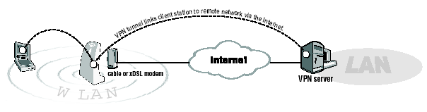
Fig.6 Access Point with VPN Pass-through

VPN works by creating a tunnel, on top of a protocol such as IP. Fig 6 represents a typical wireless LAN configuration using VPN. VPN technology provides three levels of security [7]:

- Authentication: A VPN Server should authorize every user logged on at a particular wireless station and trying to connect to WLAN using VPN Client. Thus authentication is user based instead of machine based.
- Encryption: VPN provides a secure tunnel on top of inherently un-secure medium like the Internet. To provide another level of data confidentiality, the traffic passing through the tunnel is also encrypted. Thus even if an intruder manages to get into the tunnel and intercepts the data, that intruder will have to go through a lot of effort and time decoding it (if he is able to decode it).
- Data authentication: It guarantees that all traffic is from authenticated devices thus implying data integrity.

3.3- CISCO LEAP (LIGHT WEIGHT AUTHENTICATION
PROTOCOL)
- Cisco LEAP, or EAP Cisco Wireless, is an 802.1X authentication type for wireless LANs that supports strong mutual authentication between the client and a RADIUS server. LEAP is a component of the Cisco Wireless Security Suite. Cisco introduced LEAP in December 2000 as a preliminary way to quickly improve the overall security of wireless LAN authentication. LEAP is a widely deployed, market-proven EAP authentication type.

Cisco’s LEAP fills two noteworthy WLAN security holes [4]:

- Mutual Authentication between Client Station and Access Point: We described in Section 2 (Problem Definition) of Rogue Access Points. This was because of the One-Way, Client Centered Authentication between the Client and the Access Point. LEAP requires two-way authentication, i.e., a station can also verify the identity of the Access Point before completing the connection.

- Distribution of WEP Keys on a Per-session Basis: As opposed to the static WEP Keys in 802.11 specifications, LEAP protocol supports the notion of dynamic session keys. Both the Radius Server and Cisco client independently generate this key. Thus the key is not transmitted through the air where it could be intercepted.

3.4- SSL (SECURE SOCKET LAYER)
SSL is an application level protocol that enables secure transactions of data and relies upon public/private keys and digital certificates. When using SSL in WLAN environment, once a notebook is communicating with an Access Point (using WEP), a user is NOT able to DO ANYTHING on the wireless connection until properly authenticated. This authentication is accomplished using the additional level of SSL security encryption. Since WEP alone does not ensure secure wireless communications, people are encouraged to use applications that provide encryption such as SSL-based secure websites.

The SSL protocol runs above TCP/IP and below higher-level protocols such as HTTP or IMAP (Refer to Fig. 7.). It allows mutual authentication between SSL Client and SSL Server and then form an encrypted connection.

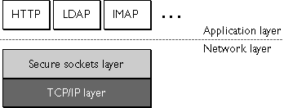

Fig.7 SSL runs above TCP and below High Level Protocols

3.4.1- Advantages Of SSL
- Encrypted communication between client and server
- Mutual authentication between client and server
- Standard on most of today’s web browsers (SSL clients)
- Easy to establish sessions
- Comparatively cheaper solution

4 - TESTBED SETUP

4.1- DESKTOP COMPUTERS
There are two Intel based desktop computers. Both of them will be associated with the Access Point to create an Infrastructure based WLAN. One of them will act as a server hosting a program that generates sample data. It also acts as a VPN server and/or as an authentication server etc., depending on the underlying method being employed in an experiment. The second computer will act as a client of VPN, LEAP or SSL etc., depending on the underlying method being employed in an experiment. Refer to figures 8, 9, 10, and 12 for the various configurations.

4.1.1- Hardware Configuration

- Processor: Intel Pentium II 400MHz
- RAM: 256MB
- Network Adapter: Cisco Aironet 350 Series Wireless LAN Adapter

4.1.2- Software Configuration

- Operating System: Windows 2000 Professional

- ACU (Aironet Client Utility): This utility comes with the Aironet card. It is used to perform user level diagnostics on the Cisco Wireless LAN adapter card. It allows us to upgrade firmware, look at the current device status, view current device statistics and perform a link test to assess the performance of RF link at various places in our area.

- IPSU (IP Setup Utility): It is used to get the IP address of a wireless Ethernet device based on the device MAC ID. The user may also use this utility to set the IP Address and the SSID if the device is still in default state.

4.2- LAPTOP COMPUTER
Intel based Dell Laptop will be used to try to crack the WEP key in the WEP enabled WLAN configuration. (Refer to Fig.7.) It will host a program like ‘AirSnort’ for cracking WEP key.

4.2.1- HARDWARE CONFIGURATION

- Processor: Intel Pentium III 600MHz
- RAM: 256MB
- Network Adapter: Cisco Aironet 350 Series Wireless LAN PCMCIA Adapter

4.2.2- SOFTWARE CONFIGURATION

- The same as the desktop.

4.3- ACCESS POINT
Access point is absolute necessity in case of wireless LAN running in Infrastructure mode. All traffic between the two computers in the wireless network has to pass through this Access Point. Thus it is analogous to a hub or switch in a wired LAN.

- Make and Model: Cisco Aironet 350 Series
- Data Rates Supported: 1, 2, 5.5, 11 Mbps
- Network Standard: IEEE 802.11b
- Uplink: Auto-Sensing 10/100BaseT Ethernet
- Frequency Band: 2.4 to 2.497 GHz
- Network Architecture: Infrastructure
- Wireless Medium: Direct Sequence Spread Spectrum (DSSS)
- Supports IEEE 802.1x-based Extensible Authentication Protocol (EAP) services that provide centralized, user-based authentication and single-user, single-session encryption keys
- Supports Automatic channel selection, Cisco Discovery Protocol (CDP), Dynamic Host Configuration Protocol (DHCP), and BOOTP services to simplify installation and management of WLAN infrastructures

4.4- OTHER SOFTWARE REQUIRED
Using the above stated hardware available, four different security mechanisms would be implemented. A java-based program would have to be created and executed (on the server side) for all the mechanisms (described in Sec.4.5), which would continuously dump data to the client for security and performance analysis.

Some of these mechanisms will require some extra software configurations as well which would be satisfied by making some necessary configuration changes in Access Point and Cisco client software setup (e.g. in case of WEP and LEAP) and also by employing third party software. This third party software would include:

- Airsnort utility for cracking of WEP key. (Currently widely used version of Airsnort is Linux based. If windows version could not be obtained then one of the desktop PCs would be installed with Linux operating system.)

- Radius (AAA) Server. This would be an absolute requirement in the case of Cisco LEAP approach and can also be used in the VPN approach.

- VPN Server and VPN Clients for the VPN approach. Any shareware distribution of VPN server and client can be used for this purpose.

- SSL enabled client and server for the SSL based approach

4.5- CONFIGURATION OF EXPERIMENTS
There were four solutions suggested in response to the WEP vulnerability problems. Among those, IEEE 802.1x (i.e. EAP based) and Cisco LEAP will be treated as similar solutions for analysis and testing purposes and thus our test setup will only include Cisco LEAP solution for both cases. WEP based configuration will be implemented in order to emphasize and practically demonstrate the vulnerability in WEP based security. Various test configurations are discussed and illustrated as follows:

Legends:

------ Represents security control; ____ Represents data flow

Represents interception

SP Represents a Java program that exchanges sample data with the client
- WEP Based Approach
In this approach, WEP keys will be manually configured in both desktops and Access Point to enable WEP Key based encryption. SP will generate sample data (see Fig.8). Then the Laptop armed with hacking software would try to break the WEP key.
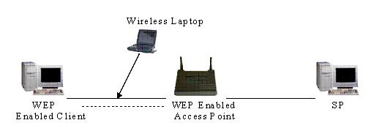
Fig.8 WEP-enabled Set-up

- LEAP Based Approach
In this approach one of the desktops will act as RADIUS server, while the client will be configured to use LEAP (Refer to Fig.9.).

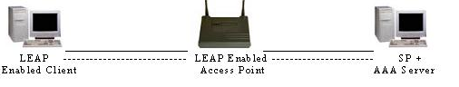
Fig.9 LEAP-enabled Set-up

- VPN Based Approach
In the VPN approach, the Access Point will be VPN aware; i.e. it will only accept and forward VPN traffic to a desktop computer configured as VPN server (and an optional AAA server). The second desktop computer will be installed with VPN client software (Refer to Fig.10.).

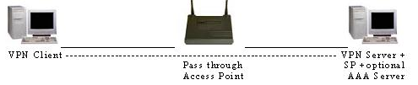
Fig.10 VPN-enabled Set-up

An alternate approach (as illustrated in Fig. 11 below) would be to have the access point act as a VPN server. However this is not the approach most widely used primarily because of performance considerations.

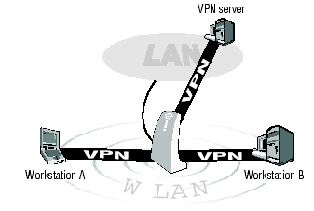
Fig.11 An Alternate VPN Solution

- SSL Based Approach
One of the desktops will be configured as a server (most probably a web server) implementing SSL. The second desktop will act as a SSL client. Again all traffic has to pass through Access Point.

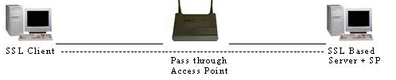
Fig.12 SSL-enabled Set-up

5 - RESEARCH PLAN

The main approach to be used is the comparative approach, i.e., to compare the security features and the performance characteristics of all the above-illustrated four approaches.

5.1- SECURITY FEATURES
To compare security features, for every approach there would be

- Theoretical Analysis of the problem in hand
- Testing (by trying to hack and attack), for example, Airsnort for WEP
- For the other approaches attempts would also be made to develop an approach to test them after extensive study in their security mechanisms is conducted.

5.2- PERFORMANCE FEATURES
A Java application will be used to generate sample data. Care will be taken to make sure that all these four approaches are tested for performance considerations under similar hardware and software environments. To test the performance of all of the above stated approaches, a program can be written or some third party tool can be made use of.

We may also make use of third party software like ‘Net Stumbler’ to perform more rigorous performance testing.

6 - THESIS TIMELINE
A tentative thesis timeline is shown in Table 2 as follows:

Months | Intended Activity
Jan 2003 | - Client Server Testing (Java) program  - Initial Study regarding IEEE 802.11B security limitations and vulnerabilities
Feb 2003  March 2003 | - WEP security study (Continued)  - WEP key cracking
April 2003 | - Cisco LEAP Study and Testing
May 2003 | - VPN Approach Study and Testing
June 2003 | - SSL Approach Study and Testing
July 2003 | - Aggregation and Analysis of Research results
August 2003 | - Writing of the Master Thesis

Table 2. Tentative Thesis Timeline

7 – REFRENCES

[1] WLAN Association, “Introduction to Wireless LANs”, WLANA Resource Center, 1999, http://www.wlana.com/learn/intro.pdf

[2] John Vollbrecht, David Rago, and Robert Moskowitz. “Wireless
LAN Access Control and Authentication”, White Papers at Interlink
Networks Resource Library, 2001. http://www.interlinknetworks.com/images/resource/WLAN_Access_Control.pdf

[3] WLAN Association, “Wireless Networking Standards and Organizations”, WLANA Resource Center, April 17 2002
http://www.wlana.com/pdf/wlan_standards_orgs.pdf

[4] Interlink Networks, “Wireless LAN Security using Interlink Networks RAD Series AAA Server and Cisco EAP-LEAP”, Application Notes at Interlink Networks Resource Library, 2002
http://interlinknetworks.com/images/resource/wireless_lan_security.pdf.

[5] Jesse R.Walker, “Unsafe at any key size; An analysis of the WEP encapsulation”, 802.11 Security Papers at NetSys.com, Oct 27 2000
http://www.netsys.com/library/papers/walker-2000-10-27.pdf

[6] Interlink Networks, “Introduction to 802.1X for Wireless Local Area Networks”, White Papers at Interlink Networks Resource Library, 2002.
http://www.interlinknetworks.com/images/resource/802_1X_for_Wireless_LAN.pdf.

[7] Pierre Trudeau, “Building Secure Wireless Local Area Networks”, White Papers at Colubris.com, 2001
http://download.colubris.com/library/whitepapers/WP-010712-EN-01-00.pdf

[8] Jean-Paul Saindon, “Techniques to resolve 802.11 and wireless LAN technology in outdoor environments”, News Article at SecurityMagazine.com, Aug 08 2002.
http://www.securitymagazine.com/CDA/ArticleInformation/features/BNP__Features__Item/0,5411,77206,00.html

Appendix A: TECHNICAL TERMS
- ISM: Industrial, Scientific and Medical Frequency Band.

- UNII: Unlicensed National Information Infrastructure Frequency Band.
- Port: A port in this context is a single point of attachment to the LAN infrastructure. Note that in the 802.11 LAN case, an access point manages “logical” ports. Each of these logical ports communicates one-to-one with a station’s port.
- Authenticator: The authenticator enforces authentication before allowing access to services that are accessible via that port. The authenticator is responsible for communication with the supplicant and for submitting the information received from the supplicant to a suitable authentication server. It only acts as a pass through for the authentication exchange.
- Supplicant: The supplicant accesses the services accessible via the authenticator.
- EAP: The Extensible Authentication Protocol (EAP) is a method of conducting an authentication conversation between a user and an authentication server. Intermediate devices such as access points and proxy servers do not take part in the conversation.
- Extensible Authentication Protocol over LAN (EAPOL): 802.1X defines a standard for encapsulating the Extensible Authentication Protocol (EAP) messages so that they can be handled directly by a LAN MAC service. This encapsulated form of EAP frame is known as EAPOL. EAPOL (EAP over LANs) in case of WLANs is also termed as EAPOW (EAP over Wireless).
- RADIUS: is the standard way of providing Authentication, Authorization, and Accounting services to a network.
- WEP: Wired Equivalent Privacy
- MAC: Media Access Control

A hidden node problem occurs when a wireless node cannot hear one or more of the other nodes therefore media access protocol cannot function properly. Thus multiple nodes will attempt to transmit their data over the shared medium simultaneously causing signal interference with one another. [8]
Figures 1, 2, and 3 are pictures courtesy of http://rnvs.informatik.tu-chemnitz.de.
Fig.4 is a picture courtesy of Computer Science Department, National Chiao-Tung University, Taiwan http://netlab18.cis.nctu.edu.tw/html/802.11/slides/chap-06.pdf
Fig.5 is a picture courtesy of Interlink Networks
Fig. 6 is a picture courtesy of Colubris Networks
Fig. 7 is a picture courtesy of Netscape.com
Fig.10 is a picture courtesy of Colubris Networks.

