1. Suppose the user, in response to the prompt when running the LoopTest3 application (Figure 1 below), enters 9 as the size of the drawing board. What would be printed on the output screen? **Note:** Show the white space, if applicable, as an underscore.

|  |  |
| --- | --- |
| import java.util.Scanner;  public class LoopTest3 {  public static void **drawLine**(int size) {  for ( ; size > 0; size--) {  System.out.print("*");  }  System.out.println();  } //drawLine()    public static void main(String[] args) {  System.out.append("Enter the size of the drawing board: ");  Scanner input = new Scanner(System.in);  int size = input.nextInt();  **drawLine**(size);  } // main()  } //class **Figure 1. The LoopTest3 Application** | **Screen output:** |

s

1. Draw a flowchart to show the operations performed in the **drawLine( )** method.
2. Rewrite the **for** statement in the **drawLine( )** method as a **while** statement.
3. Rewrite the **for** statement in the **drawLine( )** method as a **do … while** statement.
4. The drawLine( ) method in Figure 1 was written as a *static* method. Rewrite it as an instance method. Make **all** necessary changes in the program below, including main( ), for this change to work.

|  |
| --- |
| import java.util.Scanner;  public class LoopTest3 {  public static void **drawLine**(int size) {  for (; size > 0; size--) {  System.out.print("*");  }  System.out.println();  } //drawLine()    public static void main(String[] args) {  System.out.append("Enter the size of the drawing board: ");  Scanner input = new Scanner(System.in);  int size = input.nextInt();  **drawLine**(size);  } // main()  } //class |

1. Suppose the user, in response to the prompt when running the LoopTest3 application (Figure 2 below), enters 9 as the size of the drawing board. What would be printed on the output screen? **Note:** Show the white space, if applicable, as an underscore.

|  |  |
| --- | --- |
| import java.util.Scanner;  public class LoopTest3B {  public static void drawShape(int size) {  for (; size > 0; size--)  System.out.print(size);  System.out.println();  } //drawShape()  public static void main(String[] args) {  System.out.append("Enter the size of the drawing board: ");  Scanner input = new Scanner(System.in);  int size = input.nextInt();  drawShape(size);  } // main()  } //class **Figure 2. The LoopTest3B Application** | **Screen output:** |

**s**

1. Suppose the user, in response to the prompt when running the LoopTest3 application (Figure 2 below), enters 9 as the size of the drawing board. What would be printed on the output screen? **Note:** Show the white space, if applicable, as an underscore.

|  |  |
| --- | --- |
| import java.util.Scanner;  public class LoopTest3C {  public static void drawShape(int size) {  int temp = size;  for (; size > 0; size--)  System.out.print(size);  System.out.println();  int count=1;  for (; count <= temp; count++)  System.out.print(count);  System.out.println();  } //drawShape()    public static void main(String[] args) {  System.out.append("Enter the size of the drawing board: ");  Scanner input = new Scanner(System.in);  int size = input.nextInt();  drawShape(size);  } // main()  } //class **Figure 3. The LoopTest3C Application** | **Screen output:** |

1. **Program Design:** Solve the following problem by showing the design of your solution as a flowchart.

**The problem –** The program will take two integers from the user, say n1 and n2. It will then print the sum of all numbers between n1 and n2, inclusive. For example, if the user enters 5 and 9, the program will print the value of 5+6+7+8+9. On the other hand, if the user enters 5 and -2, the program will print the value of 5+4+3+2+1+0+(-1)+(-2). **Note:** Do not assume the user will always enter the smaller number first.

**The flowchart –**

1. **(Continued from above)** Show your design to the same problem as pseudocodes.

**The pseudocodes -**

1. **(Continued from above)** Write a Java application to implement your design to that problem.
2. Suppose the user, in response to the prompt when running the LoopTest application (Figure 4 below), enters 5 as the size of the drawing board. What would be printed on the output screen? **Note:** Show the white space, if applicable, as an underscore.

|  |  |
| --- | --- |
| import java.util.Scanner;  public class **LoopTest** {  public static void drawSpace(int space) {  for (; space > 0; space--)  System.out.print(" ");  } //drawSpace()  public static void drawStar(int star) {  for (; star > 0; star--)  System.out.print("*");  } //drawStar()    public static void drawLine(int size) {  int space = 0; //initial line has no space  int star = 1; //each line has one star  while (size > 0) {  drawSpace (space);  drawStar (star);  space++;  size--;  } //while  } //drawLine()  public static void main(String[] args) {  System.out.append("Enter the size of the drawing board: ");  Scanner input = new Scanner(System.in);  int size = input.nextInt();  drawLine(size);  } // main()  } //class **Figure 4. The LoopTest Application** | **Screen output:** |

1. Suppose the programmer’s original intention was to print something as shown in Figure 5 below. Add one (and only one) statement to the LoopTest program in Figure 4 so it will display the correct output as shown in Figure 5. **Note:** Clearly mark in Figure 4 where the statement is to be added.

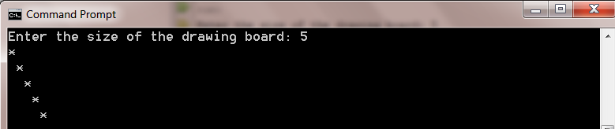

**Figure 5. Screen output by LoopTest**

1. When running the application LoopTest2, as shown in Figure 6, the user enters 6 in response to the prompt. Show the screen output. **Note:** Show the white space, if applicable, as an underscore.

|  |  |
| --- | --- |
| import java.util.Scanner;  public class LoopTest2 {  public static void **drawShape**(int size) {  int line = 1;  for (; size > 0; size--) {  int count = line;  while (count > 0) {  System.out.print(line);  count--;  }  line++;  System.out.println();  } //for  } //drawShape()  public static void main(String[] args) {  System.out.append("Enter the size of the drawing board: ");  Scanner input = new Scanner(System.in);  int size = input.nextInt();  **drawShape(size);**  } // main()  } //class  **Figure 6. The LoopTest2 Application** | **Screen output:** |

1. When running the application LoopTest4, as shown in Figure 7, the user enters 6 in response to the prompt. Show the screen output. **Note:** Show the white space, if applicable, as an underscore.

|  |  |
| --- | --- |
| import java.util.Scanner;  public class LoopTest4 {  public static void **drawNumbers**(int size) {  for (int line = 1; line <= size; line++) {  System.out.printf("line %d: ", line);  int start = line;  while (start <= size) {  System.out.print(start);  start++;  } //while  System.out.println();  }//for  } //drawLine()  public static void main(String[] args) {  System.out.append("Enter the size of the drawing board: ");  Scanner input = new Scanner(System.in);  int size = input.nextInt();  **drawNumbers**(size);  } // main()  } //class  **Figure 7. The LoopTest4 Application** | **Screen output:** |

1. Suppose it is desirable to change the LoopTest4 program in order to produce the following screen output (Figure 8). Mark the changes you’ll need to make in Figure 7.

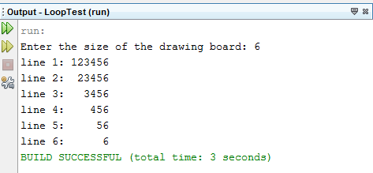

**Figure 8. The Desired Output by the Revised LoopTest4 Application**

1. When running the application LoopTest7, as shown in Figure 9, the user enters 5 in response to the prompt. Show the screen output. **Note:** Show the white space, if applicable, as an underscore.

|  |  |
| --- | --- |
| import java.util.Scanner;  public class LoopTest7 {  public static void **drawShape**(int size) {  int space = size-1; //initial number of spaces per line  int count = 1; //initial number of numbers per line  for (int line = 1; line <= size; line++, space--, count += 2) {  for ( int spaceCount=0; spaceCount < space; spaceCount++) {  //print spaces  System.out.print(" ");  }  while (count > 0) { //print numbers  System.out.print(line);  count--;  } //while  System.out.println();  }//for  } //drawShape()  public static void main(String[] args) {  Scanner input = new Scanner(System.in);  System.out.append("Enter an odd number between 0 and 9: ");  int size = input.nextInt();  for (; size > 9 || size < 0 || size%2 == 0;) {  System.out.append("Enter an odd number between 0 and 9: ");  size = input.nextInt();  }  **drawShape**(size);  } // main()  } //class **Figure 9. The LoopTest7 Application** | **Screen output:** |

1. Suppose the programmer’s original intention was to print something as shown in Figure 10 below. Clearly mark in Figure 9 where the changes would need to be applied.

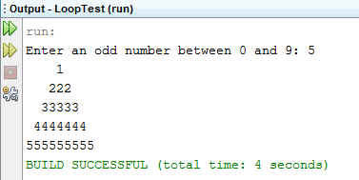

**Figure 10. The Desired Output by the Revised LoopTest7 Application**