Instructions to Run Tunnel Server
- Try to get three java files by name
- TunnelServer.java
- TunnelThread.java
- JDBCTest.java
These three files are posted under the files directory of the discussion group.
Important Note:
- Use a unique application port Number for TunnelServer at DCM, may be unique like last 4 digits of your student id.
Put the same number in JDBCTest.java
Eg:
java -cp . -Djavax.net.ssl.keyStore=clientKeyStore -Djavax.net.ssl.keyStorePassword=password -Djavax.net.ssl.trustStore=clientKeyStore com.isnetworks.crypto.net.TunnelServer 129.7.167.10 1525 9600 local
This is to run Tunnel Server at DCM.
And
in the JDBCTest.java replace 1521 with the same port number you give for the tunnel server as:
private static final String DB_URL="jdbc:oracle:thin:@localhost:1525:NAS";

- Remember there are at times some problems with the ports at Diamond or DCM, which says “java.net.BindException: Address already in use”
In this case you might have to change the port number. Change the port number as somebody else might be using the same port number on diamond or DCM.

DCM

  - You need to create keystores for client as well as server. The client side keystore we use in DCM and server keystore should be used in diamond.
The commands for creating keystores are as follows:

keytool -genkey -keyalg RSA -keystore serverkeystore
keytool -genkey -keyalg RSA -keystore clientkeystore

keytool -export -keystore serverkeystore -file server.cer
keytool -export -keystore clientkeystore -file client.cer

keytool -import -file client.cer -alias client -keystore serverkeystore
keytool -import -file server.cer -alias server -keystore clientkeystore

Remember the above statements implicitly create the client and server certificates, you don’t need to create the certificates explicitly.
The output files of the above statements are clientkeystore, serverkeystore, client certificate and server certificate.

- Try to save the files under the directory dcm../jsp/WEB-INF/classes, of course you can save these files anywhere.
- Compile the files:
If you include the package com.isnetworks.crypto.net;, the class file should go com/isnetworks/crypto/net directory.
If you do not want the packages, remove the package statement and compile. The class file should be in the same directory as the source file.
- Place classes12.zip in the current directory or anywhere. If you don’t want to give this in the classpath unzip it in the current directory, if not you have to explicitly give the path in the classpath.
You need this jar file for loading the oracle driver.
- Below is a batch file to run Tunnel Thread at DCM,

java -cp . -Djavax.net.ssl.keyStore=clientKeyStore -Djavax.net.ssl.keyStorePassword=password -Djavax.net.ssl.trustStore=clientKeyStore com.isnetworks.crypto.net.TunnelServer 129.7.167.10 1521 9999 local

DIAMOND

- The diamond machine currently uses jdk1.2 version, which does not support our SSL stuff. Hence we need jdk1.4 version to be our default java.
You need to change the path environment variable in diamond.
There is .login file in your account,
- Type vi .login
- Go to path line, add or replace the existing jdk1.2 with /compilers/j2sdk1.4.1_02/bin/
- Type source .login to make the changes effected.

  - Try to copy the following files anywhere into your diamond server TunnelServer.java, TunnelThread.java, serverkeystore, server certificate, client certificate
  - Try to make a batch file , runserver.bat with the following lines

java -cp . -Djavax.net.ssl.keyStore=serverkeystore -Djavax.net.ssl.keyStorePassword=password -Djavax.net.ssl.trustStore=serverkeystore com.isnetworks.crypto.net.TunnelServer localhost 1521 9999 remote

Open three windows, telnet one to diamond, and other two to dcm.
Run the Tunnelserver at Diamond by using runserver.bat
Run the Tunnelserver at DCMby using runclient.bat
In the third window run the JDBCTest.java .

You should be able to see the following output:

Diamond side TunnelServer

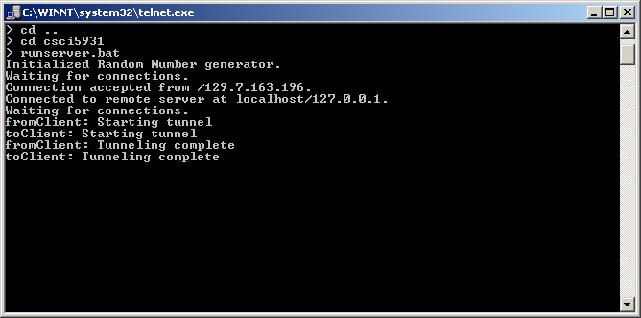

DCM side TunnelServer
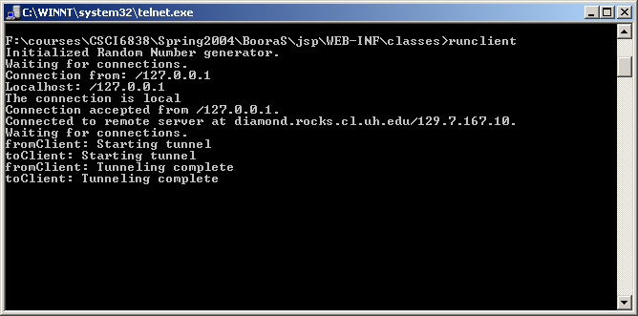

DCM side JDBCTest
