Instructions to Run TunnelServer on DCSL
Prepared by Shamima Rahman
Date Created: 10/21/05

Please follow the following steps in order to run the TunnelServer (GS book: Chapter 10) example on DCSL.

Step 1: Create tables on MySQL to use in the example,
- Download MySQL Query Browser from http://dev.mysql.com/downloads/query-browser/1.1.html and install it in your computer (for this example, the version of MySQL Query Browser that requires only to be unzipped in c: drive, is used).
- The DBMS MySQL is located on the Application Server. In order to use MySQL you must be either inside the DCSL Network or connected to the network through VPN. So if you are outside DCSL network, first get connected to DCSL directly or using VPN. Follow the instructions at http://www.dcsl-uhcl.net/public/userinfo/dcslvpn.html regarding VPN connection and FTP to the Web-Server.
- Now open up a MySQL Query Browser window and type ‘192.168.6.16’ as Server Host and 3306 as Port. Then enter your username and password. Username is lastname followed by the first letter of your firstname, and password is your student ID. For example, if a students name is 'John Doe' and Id is 0123456, then his username and password would be ‘Doej’ and 0123456 respectively.
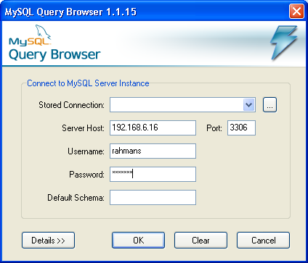
Figure 1: Connecting to MySQL Server

- Once you are logged on to the MySQL Server, select the database to work on (execute ‘use database_name’). In this case the database has been created from before and the database name for each user would be same as his/her username- ‘lastname followed by the first letter of your firstname’. (In case of the example mentioned above, the database name would be ‘doej’)
- Now proceed by creating tables, inserting data etc.
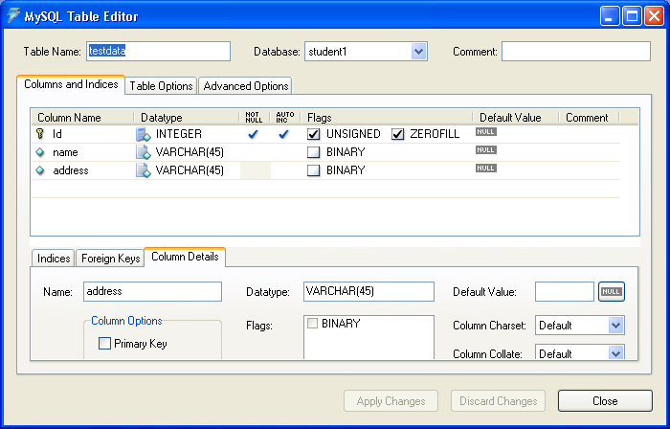
Figure 2: Creating a table on MySQL Server
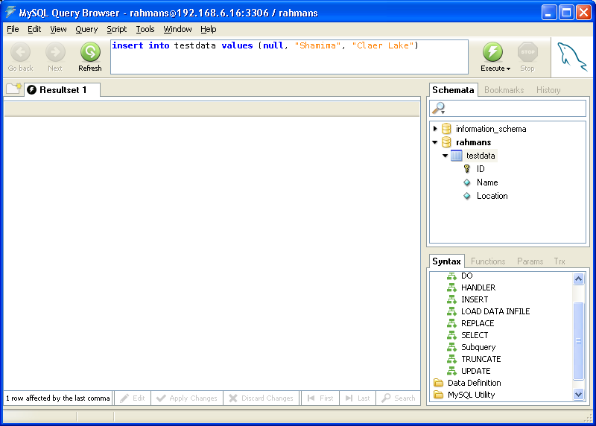
Figure 3: Inserting data into a table on MySQL Server

Step 2: Generate keystore for the client side of the TunnelServer example,
- Create the client key and the keystore with the following command,
keytool -genkey -keyalg RSA -keystore clientkeystore
- Export the client key to a file,
keytool -export -keystore clientkeystore -file client.cer
- Email the client key (for this example, ‘client.cer’ file) to rahmanshamima@yahoo.com at least 24 hours ahead of your plan to run the program, in order to get the client key added to the server keystore.
- The server key (server.cer) is available on the course’s yahoo group site. Download the key and add it to your client keystore.
keytool -import -file server.cer -alias server -keystore clientkeystore

As output of the above commands you will have the clientkeystore with the server key imported to the clientkeystore and client certificate file.

Step 3: Store the necessary files on the Web-Server,
- Try to get the following three java files by name
- TunnelServer.java
- TunnelThread.java
- JDBCTest.java
- Now transfer the clientkeystore, client certificate file, TunnelServer.java, TunnelThread.java and JDBCTest.java to the Web-Server through FTP. [In order to transfer files to the server through FTP you must be either inside the DCSL network or connected to the network through VPN.]
- Notice one point here after establishing the ftp connection you will see a folder named ‘tomcat’ in your directory. This folder is mapped to Tomcat5.5.9. And if you want to execute the example as a JSP/Servlet page, you will have to save it into this folder in order to have them executed by Tomcat. The URL convention to access those files would be http://www.dcsl-uhcl.net:8080/accountname/filename
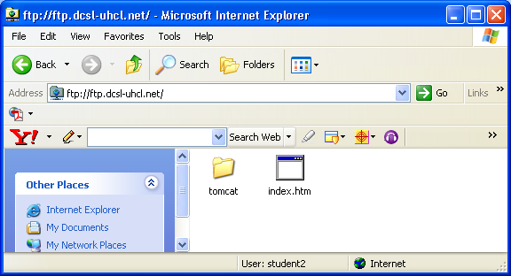
Figure 4: FTP directory on the Web-Server

Step 4: Run your TunnelServer program on the Web-Server,
- In order to run the TunnelServer program connect to the Web-Server through telnet using VPN: open up a command prompt window and type ‘telnet 192.168.7.10’. Then enter your username and password. Again username is lastname followed by the first letter of your firstname, and password is your student ID.
- Now go the directory where you have saved the files and compile the java files. Then execute the following command to run the client process of the TunnelServer program
java -Djavax.net.ssl.keyStore=clientkeystore -Djavax.net.ssl.keyStorePassword=password -Djavax.net.ssl.trustStore=clientkeystore TunnelServer 192.168.6.16 3300 6543 local

Important Note:
- You must use a unique application port number (the first port number) for the client process of TunnelServer at DCSL, and use the same number port number in JDBCTest.java also.
For example,
java -cp . -Djavax.net.ssl.keyStore=clientKeyStore -Djavax.net.ssl.keyStorePassword=password -Djavax.net.ssl.trustStore=clientKeyStore com.isnetworks.crypto.net.TunnelServer 129.7.167.10 3300 6543 local

And use the same port number in the JDBCTest.java:
private static final String DB_URL="jdbc:mysql://localhost:3300/student1";
- Here you may get the error “java.net.BindException: Address already in use” sometimes, which means the port number you have specified, is already in use (3300 for this example). In this case you might have to change the port number, as somebody else is using the same port number on the Web-Server.
- Also the 2nd port number parameter (in this case 6543) must be always 6543, as the server process of TunnelServer on the Application server is listening to requests on port 6543.
- The server process of TunnelServer is already running on the Application Server(192.168.6.16, the machine with the MySQL DBMS) and the necessary commands (creating the keystore etc.) has already been performed for that.
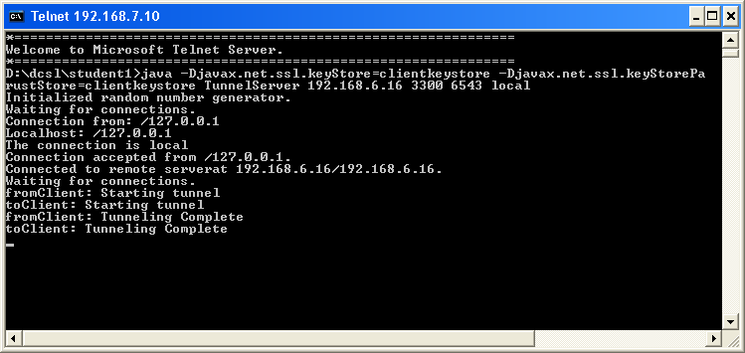
Figure 5: A snapshot of the client process of TunnelServer

Step 5: Run the JDBCTest.java on the Web-Server,
- Open up another command prompt window and type ‘telnet 192.168.7.10’. Then enter your username and password. Again username is lastname followed by the first letter of your firstname, and password is your student ID.
- Now go the directory where you have saved the files and type ‘java JDBCTest’
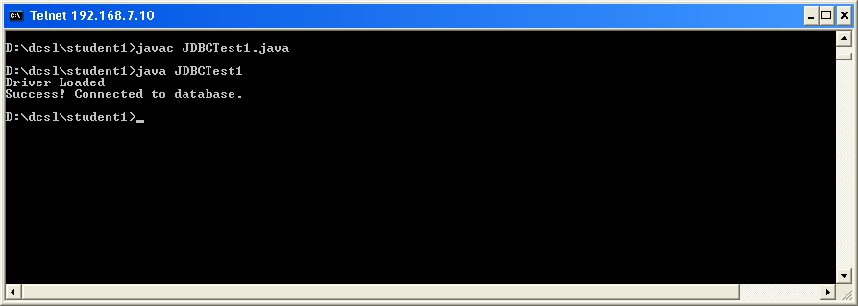
Figure 6: A snapshot of the output of JDBCTest

Now wait for few seconds and see the result of your hard work!!! GoodLuck!!!

